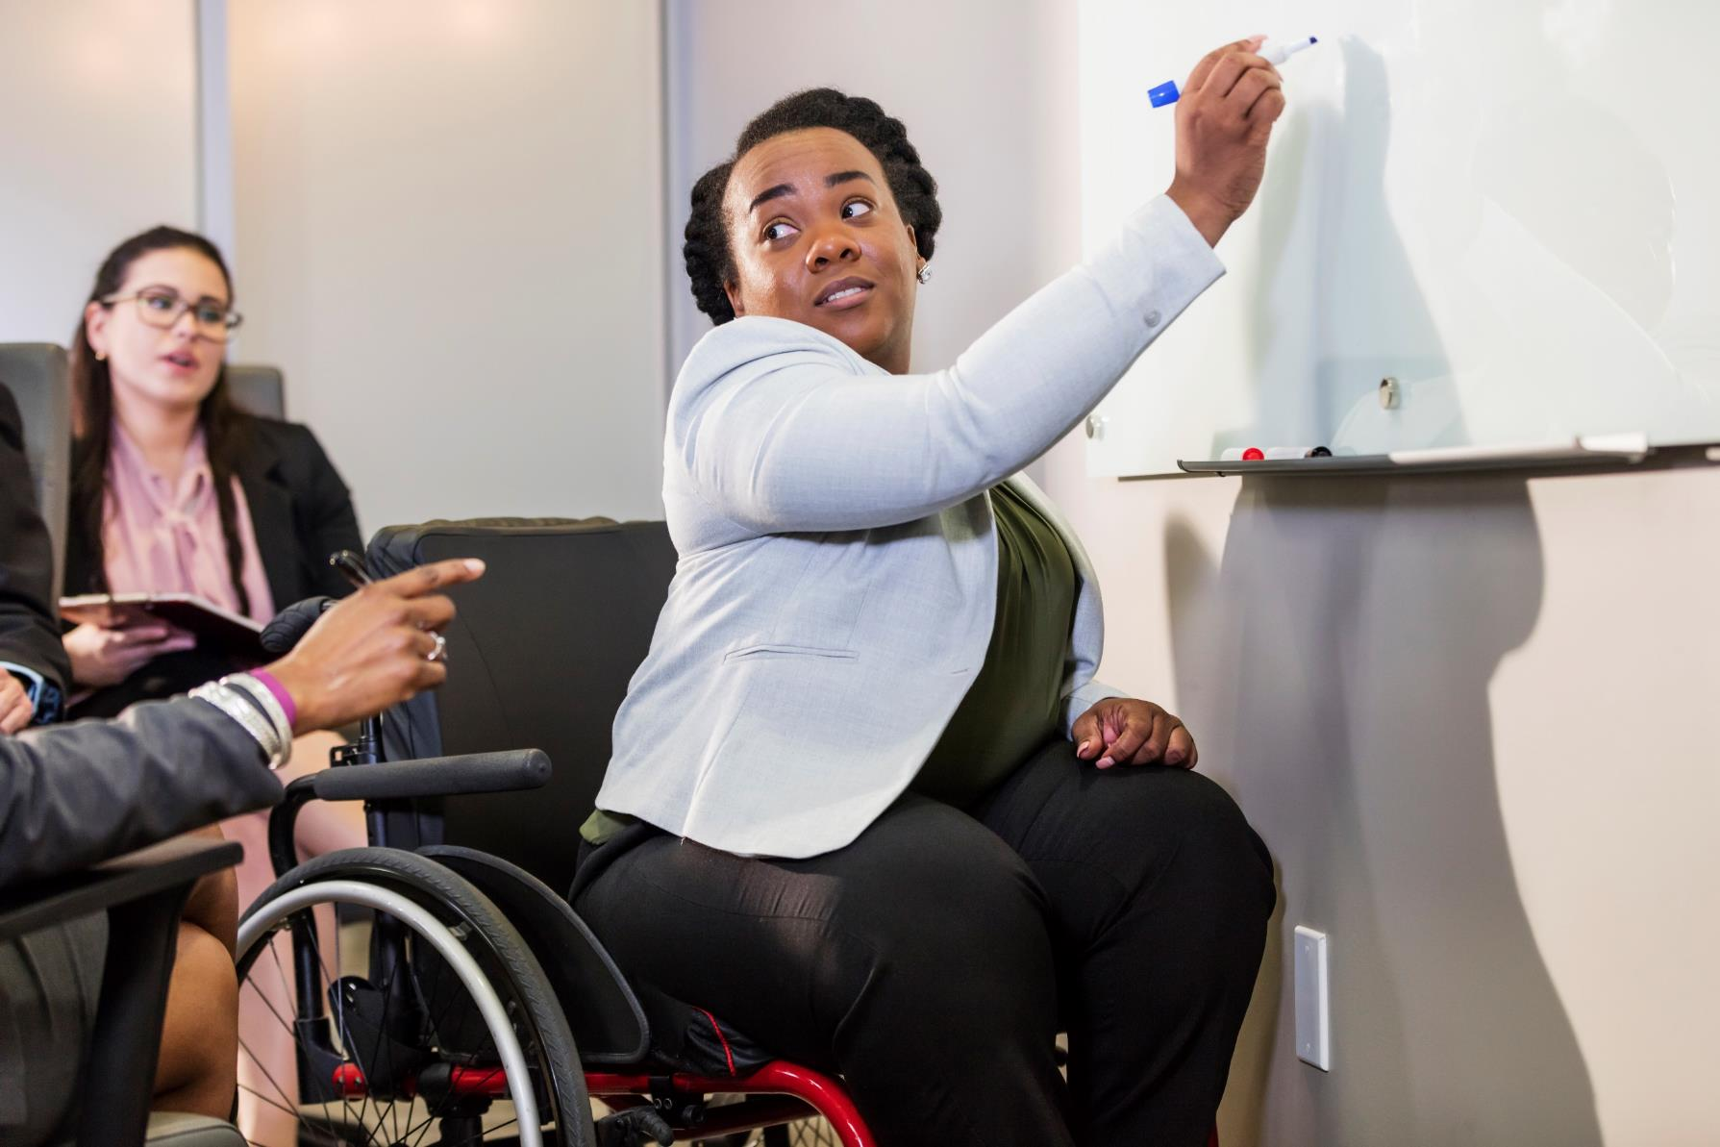

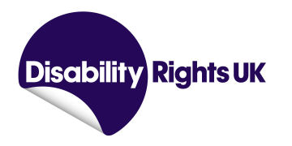

**Make It Together Project Manager**

Application Deadline: 9am on Tuesday 27th May 2025

**Job Pack**

**Welcome from our CEO**

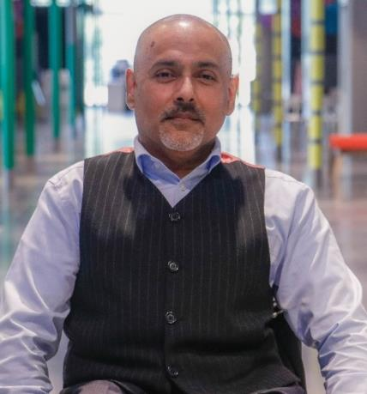

**Thank you for your interest in this role of at Disability Rights UK.**

Having entered our second decade, this is an exciting time to join DR UK. We are a Disabled People’s Organisation (DPO), which is an organisation for Disabled people that is led and controlled by Disabled people where at least 75% of the board and 50% of staff identify as Disabled. We actively demonstrate our commitment to the Social Model of Disability through our work and hiring practices.

We are part of a UK wide movement of Disabled people led organisations and Disabled people campaigning for equity, equality and inclusion to be embedded in everyday life. We have built key partnerships with allies and funders and have an effective working relationship with government departments and policy makers.

The last few years have been very difficult for Disabled people and their organisations – during the pandemic our hard-won rights were challenged, and Disabled people are being disproportionately affected by the cost-of-living crisis. We were never more needed than now.

Within this document you will find background information about the organisation, job description, person specification and information about how to apply. If you would like a chat about the vacancy, or have any questions, please contact us at [recruitment@disabilityrightsuk.org](mailto:recruitment@disabilityrightsuk.org)

**Kamran Mallick**

**CEO of Disability Rights UK**

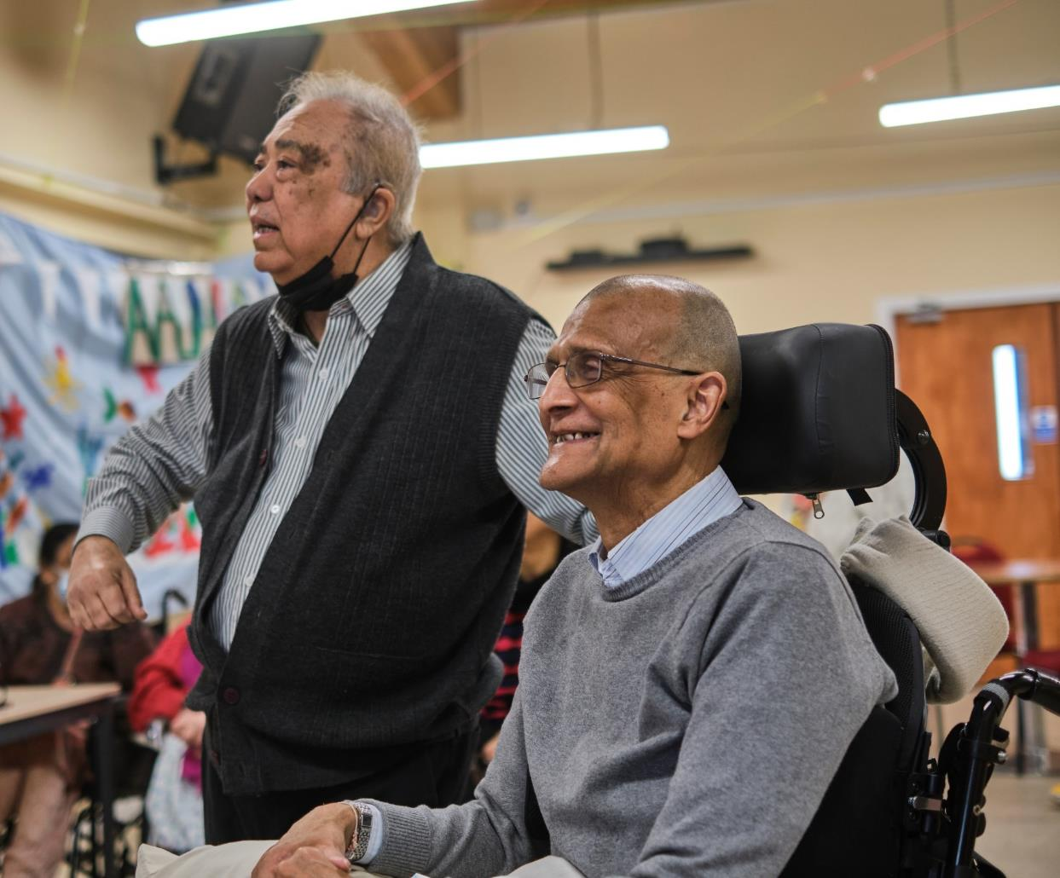

**About Us**

We had 10,000 contacts with individuals through events and our independent living advice line, student and members helpline and information line.

In 2020, as we went into lockdown and closed the office, we set up a weekly meeting of CEOs and Policy staff from Disabled People’s Organisations. The group, Our Voices continues to meet, sharing knowledge, speaking with a unified voice on the inequalities that continued through the pandemic.

Our Disability Rights Handbook continues to be a vital support for Disabled people. Written by benefits specialists, this guide to benefits is now published online and in print.

We work in partnership with funders to test ways to break down systemic barriers faced by Disabled

**We are Disabled people leading change**

Disability Rights UK is the leading charity of its kind in the UK. We are run by and for people with lived experience of disability or health conditions.

We are committed to the Social Model of Disability and led by people with lived experience of disability or long-term health conditions. 85% of our trustees have personal experience.

DR UK is a member-led charity, with disabled people and organisations led by disabled people having the controlling vote.

We are committed to working with and for people with all types of impairment and health conditions.

**Last year we reached more than 1.2 million people with information developed by and for disabled people**

Our free factsheets attracted 1.8 million downloads and over 90% of users said our factsheets were useful to their purposes.

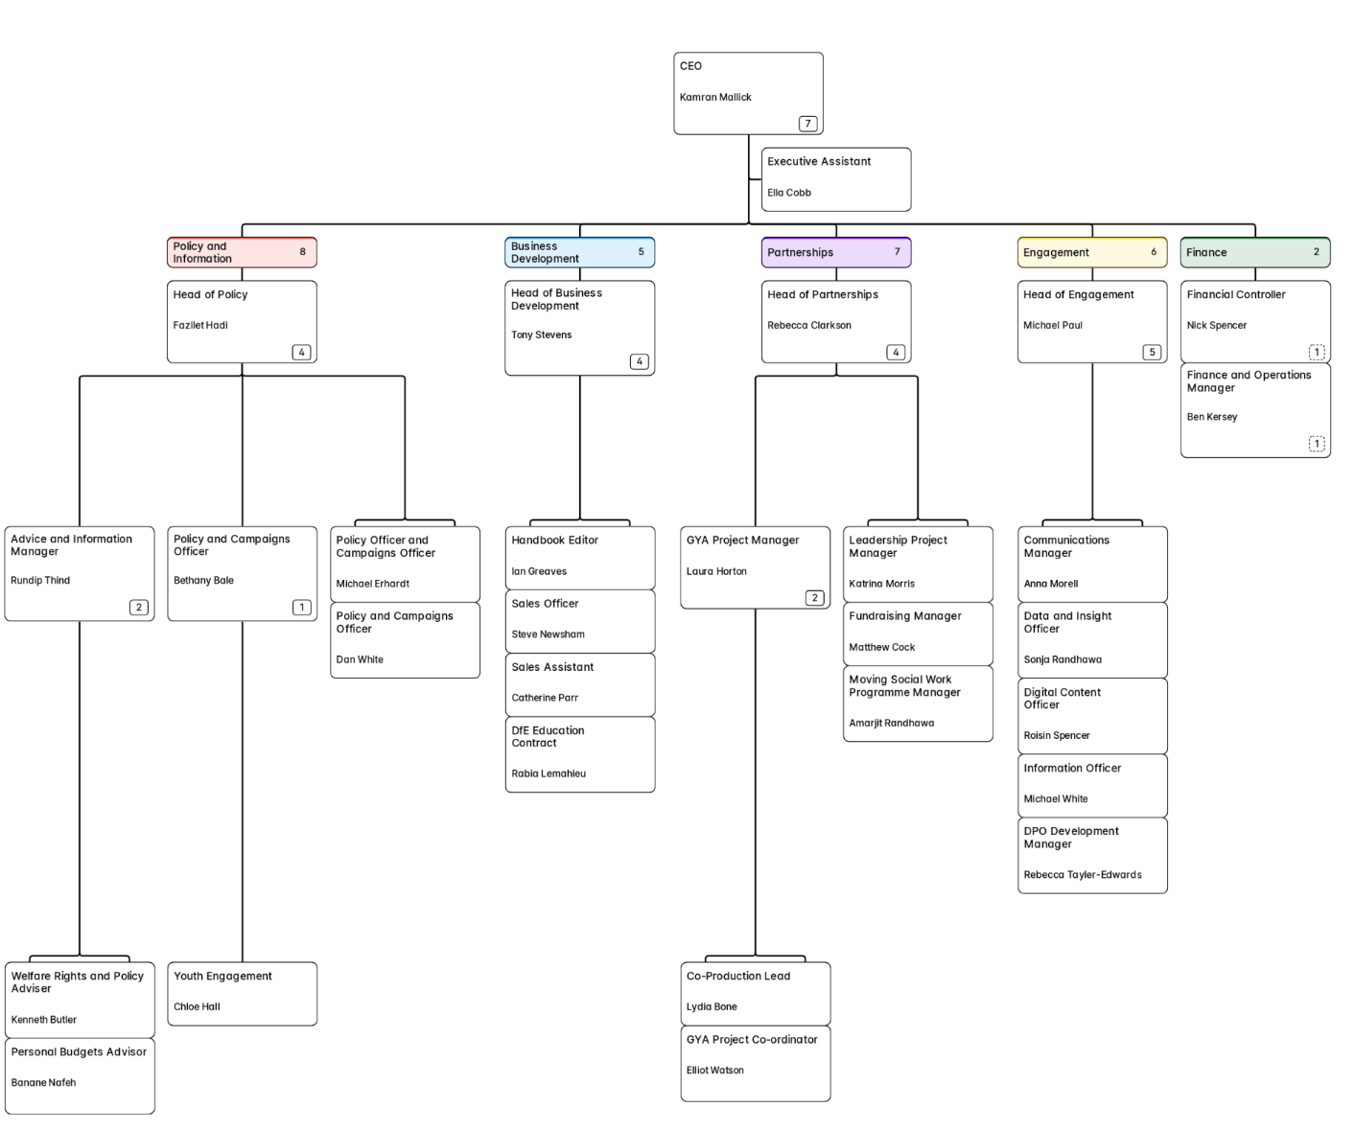

**Our Structure**

**The Role**

**About the Project: Make It Together**

Make It Together is a 9-month, Arts Council England-funded project that brings together Disabled People’s Organisations (DPOs) and national arts and culture partners to unlock inclusive everyday creativity across three pilot locations: Manchester, Barking & Dagenham, and Wiltshire.

The project embeds Creativity Connectors within local DPOs to bridge the gap between Disabled creatives and community-based creativity groups. The project will develop and share two national toolkits and culminates in an online Symposium in January 2026.

**About the Role**

We are looking for a creative, enthusiastic and collaborative Project Manager to lead the coordination and delivery of Make It Together. This is a unique opportunity to help shape a high-impact, co-produced, disability-led project that aims to spark long-term systemic change in everyday creativity and inclusion.

You will be the glue holding the partnership together—supporting delivery partners, managing timelines and budgets, facilitating communication, and ensuring that the voices and experiences of Disabled people remain central at every stage.

**Key Responsibilities**

**General Project Delivery**

* Manage day-to-day operations, timelines, budget tracking and communications.
* Be the primary point of contact for the project.
* Ensure delivery of project activities, outputs, and reporting obligations to steering group and funder.
* Produce timely narrative and financial reports with support from the DR UK Finance and Fundraising teams.
* Support exploration of funding for a potential Phase 2.

**Stage 1: Project Set-Up (circa Jun–Sep 2025)**

* Support DPO partners in recruiting and onboarding Creativity Connectors.
* Convene and facilitate the Project Steering Group.
* Liaise with national partners including Creative Lives, Attitude is Everything, The Audience Agency, and 64 Million Artists.
* Coordinate setup and delivery of training for Creativity Connectors.
* Support co-production of a project evaluation framework with The Audience Agency and partners.
* Oversee the setup of the online Disabled Everyday Creatives Network

**Stage 2: Research & Engagement (circa Oct–Dec 2025)**

* Support Creativity Connectors to:
  + Map local everyday creativity groups and practices.
  + Run inclusive focus groups / Knowledge Cafés to explore barriers, opportunities, and solutions.
* Ensure strong communication and shared learning between DR UK, local and national partners

**Stage 3: Legacy & Dissemination (circa Jan–Feb 2026)**

* Coordinate co-production of inclusive Everyday Creativity Toolkits.
* Organise and deliver an online Symposium and EasyRead Symposium.
* Oversee project evaluation and contribute to the final evaluation report.

**Person Specification**

**Experience**

* Project management
* Managing budgets
* Arts / cultural sector experience
* Working on partnership projects
* Commissioning and undertaking evaluation

**Knowledge**

* Knowledge of the barriers that Disabled people experience in society, and the Social Model of Disability
* Accessible and inclusive practice in areas relevant to the project: e.g. in-person and online events, communication

**Skills and Abilities**

* Building strong relationships internally and externally
* Managing a varied workload, taking initiative and working to deadlines

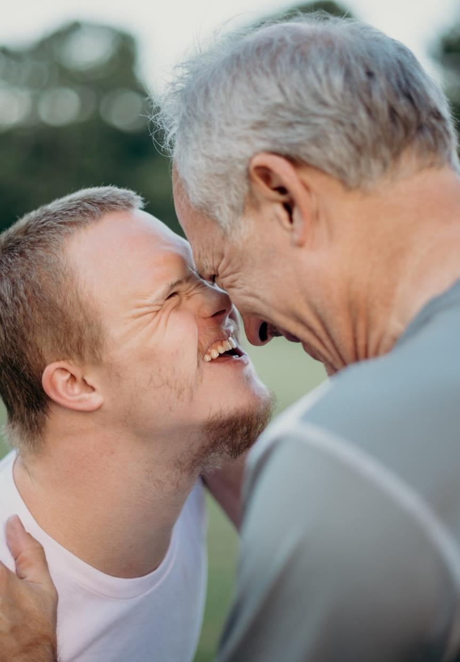

**Role Details**

**This is a full time, fixed term role funded for nine months, starting as soon as possible. The salary on offer is £40,101 - £44,201, dependent upon experience.**

DR UK is based in East London’s Olympic Park, and the role will be a combination of office and remote working. There may be occasional travel and overnight stays as required.

Annual leave entitlement is 25 days plus all public holidays plus 3 days closure between Christmas and New Year.

Benefits include flexible working and a work-based pension with employee contributions of 5% plus contributions of 5% from DR UK. DR UK colleagues have access to a website providing discounts at many major retail outlets. We also provide an employee assistance programme.

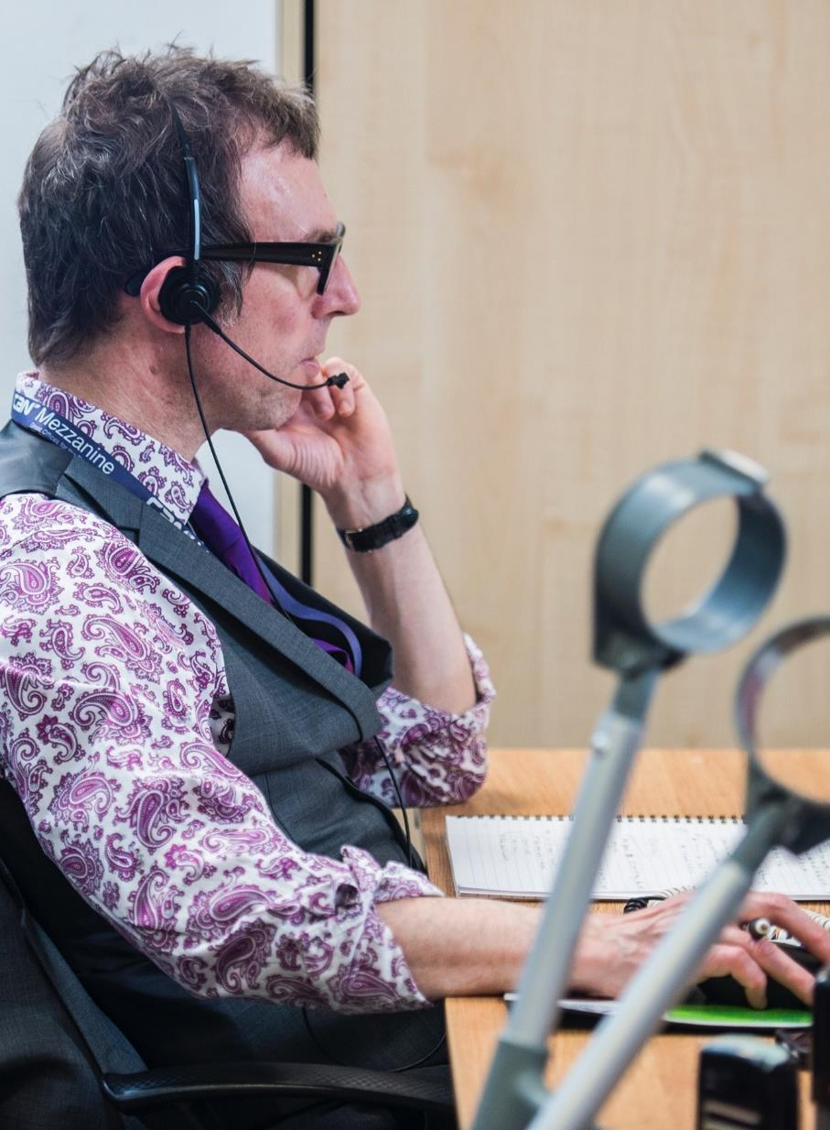

**How to Apply**

To apply, please send us your CV along with a covering letter, to tell us why you want the job and, ideally, using the Person Specification to outline how you meet the requirements. Your covering letter can be up to up to 1,000 words in length. **The deadline is 9.00am on Tuesday 27th May 2025. Interviews will be held remotely during week commencing Monday 2nd June 2025.**

Should you wish to have an informal chat about the role, which we encourage, wish to apply using another format, or need adjustment to enable you to apply, please contact us via 0203 687 0785 or [recruitment@disabilityrightsuk.org](mailto:recruitment@disabilityrightsuk.org).

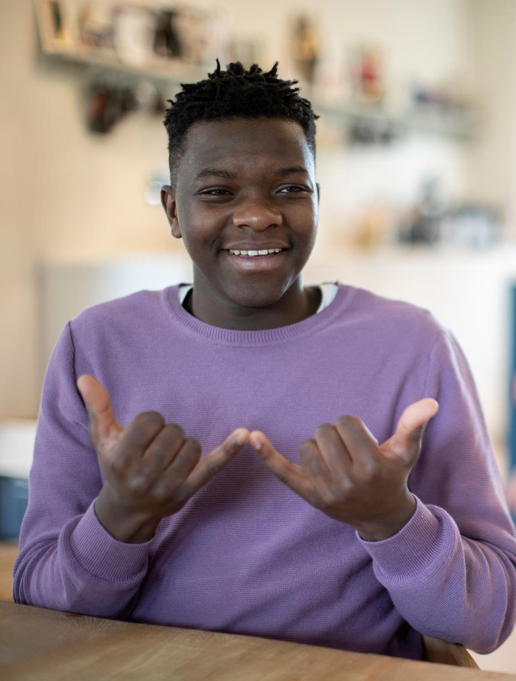

**Next Steps**

* Contact us to have an informal chat about the role
* Send your cover letter and CV to us
* We will interview all suitable candidates
* We will let you know the outcome within a week

We want to see the best of you at every stage of the process. Tell us about any adjustments you need to give you the best experience of this process and to remove barriers at every stage.

**Other Information**

We acknowledge that people from certain backgrounds are under-represented in our sector, and we’re committed to doing what we can to correct this. We are particularly keen to receive applications from Disabled people; Black, Asian and minority ethnic people; people who identify as being LGBTQIA2S+; and people who identify as working class now or in the past.

**GDPR personal data notice:**

As part of any recruitment process, DR UK collects and processes personal data relating to job applicants. In order to carry out the recruitment process we will share the personal data received from you in your application with the shortlisting and interview panel. Access will be restricted to those involved in the recruitment process.