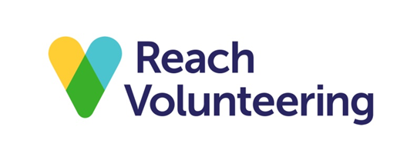

Doing a skills audit
An effective charity board has trustees with a good range of skills and qualities, and a variety of professional and personal experience. The ideal mix will depend on the nature of the charity, but having a diverse board – where trustees have different experiences and perspectives – will help to ensure the board will make well-rounded decisions.
A skills audit is a useful tool for mapping out the skills and expertise of trustees to see if you have the right mix and to identify any gaps in the board’s overall skills. It will also let you see how it may be affected if a trustee leaves or your charity faces any new challenges.

When to do a skills audit
The most common time to do a skills audit is when you recruiting new trustees. However, skills audits should be done regularly – at least annually – because your trustees’ skills and experience will change, and you will be able to respond more quickly when you need new trustees if you already have an up-to-date skills register.

What an audit should cover
Your board needs the expertise to:
- exercise overall control of the organisation’s current business operations
- manage the charity’s resources responsibly
- set the strategy and oversee its implementation
- ensure that the needs of your organisation’s beneficiaries are put first
- keep the charity true to its purpose.
Skills audits are good for reflecting on the functional skills that your board needs. They can also focus on other aspects of your board, such as diversity. Does your board reflect the community that you serve in terms of gender, age, ethnicity, disability, lived experience and/or class? Is there a role for service users on your board?

How to do a skills audit
You can do a skills audit in various ways. You could ask each trustee to complete a printed or online audit and then you could collate the results. Alternatively, the chair could complete the audit as part of an annual face-to-face appraisal with each trustee. Or you could ask an external advisor to undertake an audit.
We have a sample skills audit that you can use or adapt for your charity.
Organisation name: XXXX

Individual trustee skills audit
The following should be filled out by each member of the board to identify the skills they bring to the organisation.
Name:

Date:

Level of expertise: 1 = highly experienced, 2 = proficient, 3 = some experience, 4 = no experience
Skills, expertise, knowledge qualifications | Level of Expertise |  |  |  | Comments
 | 1 | 2 | 3 | 4
Administration
Board/committee experience
Campaigning
Change management
Charity/voluntary organisation governance
Conflict resolutions
Customer care
Digital
Enterprise/business development
Facilitating meetings
Finance
Fundraising
HR/Training
Income generation
Influencing
IT/systems
Leadership
Legal
Listening
Marketing
People management
PR/communications
Project management
Property/ asset management
Relationship management
Service user/beneficiary of the organisation
Team development
Voluntary sector experience
Other (Specialist experience or qualification relevant to voluntary organisations e.g. campaigning, advice, etc.)
Motivation - Do you have a particular interest or reasons for being/wanting to be a trustee of this organisation?

Diversity - A diverse board is able to reflect and support the delivery of an organisation’s mission. Do you have a specific service user experience, social or family experience, background or general interests that will help us support the goals of the organisation?

Areas or work - Are there any areas of the work of the organisation you have a particular interested in and/or would like to become more involved in?

Training and development needs - Do you have any training or development needs that would help you to fulfil your trustee role more effectively?

Networking – Are you a member of any networks personally or professionally that you think may benefit the organisation in some way?

