Disability Positive
Funding and Income Generation Strategy
2022-2030

Revision History

Version | Revision Date | Revised by | Section Revised
0.1 | 30/08/2022 | LT/ML | New Draft

Document Control

Document Owner:  FC | Document No: | Status:  Draft | Date Approved:
Security Classification:  Med | Next Review Date: | Version:  V0.1 | Department:  Finance

Introduction
Disability Positive (hereinafter referred to as the “Company”) has committed to ambitious growth as set out in the Company Strategy, across three objectives to define our work; our strategy is about what we want to achieve over the next ten years (2020 – 2030).

We want a world that is Disability Positive, where people with lived experience of disability and long-term conditions, like us, have services to help with everyday life, being part of their local community and looking after their own wellbeing. We also want to listen and share people’s experiences to influence positive change in government policy.

We have committed to increasing our reach as well as increasing our turnover from by 2030. We intend to do this by looking at several specific areas of growth
over the next 8 years, by working collaboratively with representative organisations that think like us.

Our Strategy sets out the means by which this will be achieved and aligns income generation activities with the work plan and our wider strategic objectives, as identified opportunities, as part of our Strengths, Weaknesses, Opportunities and Threats shown in Appendix A.

This funding and income generation strategy is designed to complement the Strategy. It identifies proposed sources of income, sets targets for income recovery levels and proposes specific tasks to achieve those targets.

A set of strategic objectives have been developed within this strategy. These are
summarised in Section 2 overleaf.

Strategic Objectives
1: Income projections will be based on the previous year.

2: The Income Reserve will be set at £xx until the risk profile changes to indicate that it should be revised.

3: Each of the proposals put forward at April 2022 for increasing income will be reviewed and implemented during the lifetime of the strategy with a view to generating an additional £xx by March 2030 compared to 2020/21 budgets.

4: For future income generating activities, costs of undertaking the activity will be identified and allocated against income budgets so that the extent of any recovery against overheads can be determined.

5: Each of the tenders submitted, will be reviewed during the lifetime of the strategy to monitor success.

6: The marketing strategy for the Company’s services will be reviewed to promote income generating functions alongside promotion of fundraising and corporate sponsorship opportunities.

Income Sources
Disability Positive has recognised the need to diversify and increase our income to support service delivery and has stated our intention to increase our reach as well as increasing our turnover from £xx to £xx by 2030. We intend to do this by looking at specific areas of service growth over the next 8 years, by working collaboratively with representative organisations that think like us.

The proposed approach to generating additional income will be with the following key areas of activity: -
- Investing in new business development role(s).

- Updating our 2023/24 income budgets to ensure they reflect the proposed level of activities and income anticipated on existing activities. It is anticipated that this could deliver an additional £xx of income per annum.

- Increasing income through new income opportunities, associated with or complementary to our existing activities in the identified growth areas, through a targeted business case approach to review the potential for income growth. It is anticipated that this could deliver an extra £xx – £xx of income p.a.

Current income streams are shown in Appendix B.

Updating Income budgets
As indicated above there has been a growth in budgeted income between 2020/21 and 2021/22. The process of aligning budgets to expected income levels is already in place and will continue for future years. There are two issues to consider within this Strategy:
- What is the right level of budget to set (zero-based or incremental based)?
- What actions can be taken to mitigate risks to demand-led budgets where short-term income reductions cannot be controlled?

The answer to these questions lies partly in reviewing past income trends, existing contract security, and partly in maintaining sound forecasting techniques.

Table 1: Income Variances against budget 2020/21 and 2021/22 in growth areas

 | 2020/21 |  |  | 2021/22
 | Budget | Actual | Variance | Budget | Actual | Variance
Total Income

For the first full year of this strategy, 2023/24, all income budgets will be set on the basis of actual income recovery over the previous year. This should ensure that the £xx increase in income projected is achieved and provide a sound basis for future income projections. Future years trend data will be added to budget profiles to strengthen the evidence base for this work.
Objective 1: Income projections will be based on prior year data.

For the main income streams a combination of zero-based budgets and incremental-based budgets are being used. These use data from the past year(s) to plot month by month changes in income pattern. This means that by the end of the second quarter, likely year-end outruns can be projected with a greater degree of certainty.

With longer-term projections, however, the level of risk increases. To mitigate this,
contingencies are required to help manage reductions in income in the short term
until strategies can be put in place to re-secure the income stream. One reserve
has been created for this purpose, as follows:

Income Contingency Reserve
Our reserves have a balance of £xx at June 2022. The reserve was established
to mitigate the impact of sudden events which could radically affect income levels,
such as loss of contracts, or catastrophic failure of key equipment that could affect service delivery, and to cover the liability commitments if the Company was to cease operations. Our Reserves policy sets out the need for xx months income of £xx. The reserve will, therefore, remain static at approximately £xx until income risk profiles change.
Objective 2: The Income Reserve will be set at £xx until the risk profile changes to indicate that it should be revised.

Increasing income from existing and complementary activities
Budget alignment is the process by which growth in income is captured and translated into forecast net budgets within the Company. However, ensuring growth requires strengthening returns from existing sources and developing new income generating
opportunities.

There have been a number of activities designed to identify opportunities to diversify and increase income from existing sources or identify new ones.

We have made some progress in diversification of income, as can be seen in the mix of income for 2020/21 and 2021/22 years shown in table 2 below.

Table 2: Income mix 2020/21 – 2021/22

Income | YE 31 March 2021 | YE 31 March 2022
 | % | %
 | % | %
 | % | %
 | % | %
 | % | %

Some preparation work has commenced in areas that have identified some quick wins that could be or have been implemented relatively quickly. These are shown in figure 1 below:

Figure 1: Income generating projects

Of these four have made some significant progress:

Use of our asset(s)

Training opportunities

Consideration of a Trading Arm

Tendering Opportunities

Opportunities are listed in Appendix C.
Objective 3: Each of the proposals put forward at April 2022 for increasing income will be reviewed and implemented during the lifetime of the strategy with a view to generating an additional £xx by March 2030 compared to 2020/21 budgets.

In all cases, the income arising from the activity should be sufficient to make a
contribution to overheads as well as cover running costs to meet the Finance and Financial Controls policy.
Objective 4: For future income generating activities, costs of undertaking the activity will be identified and allocated against income budgets so that the extent of any recovery against overheads can be determined.

Approach to Tendering Opportunities
As indicated above, there are a number of opportunities that we can nurture, engage, explore or ignore as potential tendering opportunities to further support the growth of the Company and achieve objective 3. There are six issues to consider within this strategy:
- What is our approach to collaborating with others in bids?
- What does the strategy commit to for financial/service area growth?
- What regions/areas do we want to supply/grow into?
- What types of services provided are contracted through tendering?
- What is a realistic contract size to bid for?
- What types of funding sources will support our growth?

The answer to these questions lies in the timing of the tender opportunities, whether or not they are currently delivered by a representative organisation (DPO), value of the tender, and capacity at the time to complete and submit multiple bids.

Therefore, as detailed in Appendix C, those that are identified as ‘nurture’ or ‘engage’ can be prioritised in the short-medium term; with those identified as ‘explore’ to be considered in the medium-longer term. Those identified as ‘ignore’ are currently being delivered by a representative organisation.

For each tender opportunity, we would be expected to triage the opportunity by considering relevant key information for the tender before passing to the relevant Senior Manager, to provide a clear plan and timeline for writing, signing-off and final submission of the tender. This is shown in Figure 2 overleaf:

Figure 2: Triaging of Bid/Tendering Opportunities

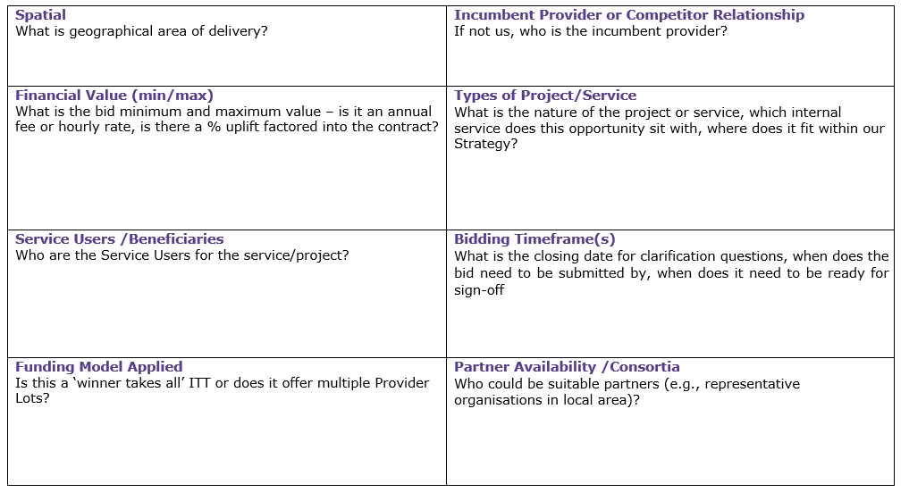

Once the tender opportunity has been triaged, the relevant Senior Manager will be responsible for arranging and overseeing the planning, writing, and submission of the final draft tender for sign off by the Chief Executive Officer/Board before any final submission to the buyer is made.
As part of the planning stage, the Senior Manager should think about the key considerations as part of the bid planning process. These are shown in figure 3.

Figure 3: Bid/Tender Review Planner

Marketing
The success of these major income schemes and other aspects of the Income Generation Strategy will depend to some extent of effective marketing of services that generate income.

To support income generation, an updated marketing strategy is needed to:
- Review key markets and potential customers
- Establish timelines for bringing new services to market as set out in Appendix C
- Create marketing and communication strategies in support of new and
- existing services
- Establish target income levels and monitoring approaches to ensure delivery
- Review risks and develop mitigating actions
Objective 5: Each of the tenders submitted, will be reviewed during the lifetime of the strategy to monitor success.

The marketing strategy forms a key component in the delivery of this Income Generation Strategy.
Objective 6: The marketing strategy for the Company’s services will be reviewed to promote income generating functions alongside promotion of fundraising and corporate sponsorship opportunities.
.

Appendix A: Our Strengths, Weaknesses, Opportunities, and Threats Analysis
Strengths | Weaknesses
Opportunities | Threats

Appendix B: Our Current Income Sources

Income Source | Activity/Service Funded | Annual Amount (£) | End Date for Funding | How secure is the funding source? | Does an alternative Source need to be identified? | Priority

Appendix C: Proposed New Sources of Income

Service | Area | Organisation | Timeline | Value | DPO  Yes/No | Action

Key
Nurture
Engage
Explore
Ignore

