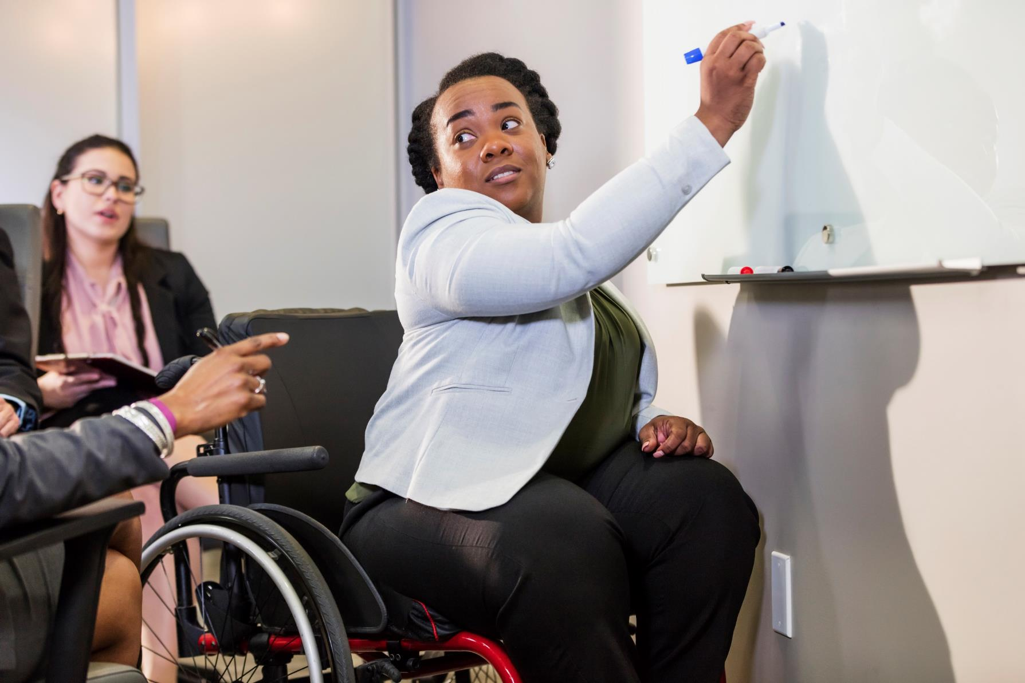

Appointment of Executive Assistant
Application Deadline: Ongoing Until Post Filled

Job Pack
Welcome from our CEO
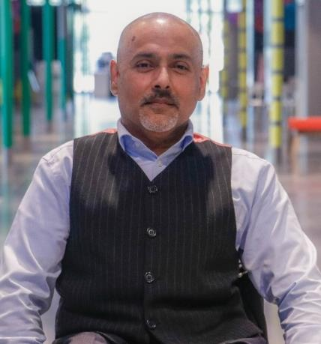
Thank you for your interest in the role of at Disability Rights UK.
Having entered our second decade, this is an exciting time to join DR UK. We are a Disabled People’s Organisation (DPO), which is an organisation for Disabled people that is led and controlled by Disabled people where at least 75% of the board and 50% of staff identify as Disabled. We actively demonstrate our commitment to the Social Model of Disability through our work and hiring practices.
We are part of a UK wide movement of Disabled people led organisations and Disabled people campaigning for equity, equality and inclusion to be embedded in everyday life. We have built key partnerships with allies and funders and have an effective working relationship with government departments and policy makers.
The last few years have been very difficult for Disabled people and their organisations – during the pandemic our hard-won rights were challenged, and Disabled people are being disproportionately affected by the cost-of-living crisis. We were never more needed than now.
Within this document you will find background information about the organisation, job description, person specification and information about how to apply. If you would like a chat about the vacancy, or have any questions, please contact us at recruitment@disabilityrightsuk.org
Kamran Mallick
CEO of Disability Rights UK

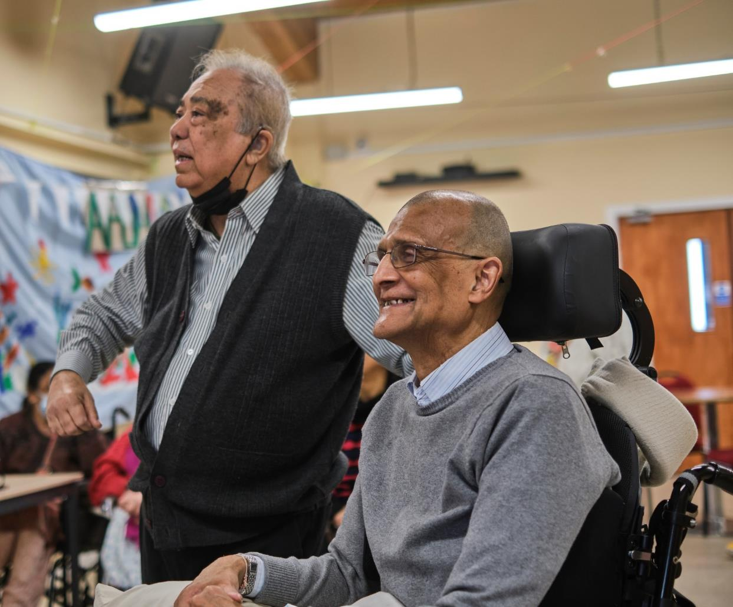
About Us
We had 10,000 contacts with individuals through events and our independent living advice line, student and members helpline and information line.
In 2020, as we went into lockdown and closed the office, we set up a weekly meeting of CEOs and Policy staff from Disabled People’s Organisations. The group, Our Voices continues to meet, sharing knowledge, speaking with a unified voice on the inequalities that continued through the pandemic.
Our Disability Rights Handbook continues to be a vital support for Disabled people. Written by benefits specialists, this guide to benefits is now published online and in print.
We work in partnership with funders to test ways to break down systemic barriers faced by Disabled

We are Disabled people leading change
Disability Rights UK is the leading charity of its kind in the UK. We are run by and for people with lived experience of disability or health conditions.
We are committed to the Social Model of Disability and led by people with lived experience of disability or long-term health conditions. 85% of our trustees have personal experience.
DR UK is a member-led charity, with disabled people and organisations led by disabled people having the controlling vote.
We are committed to working with and for people with all types of impairment and health conditions.
Last year we reached more than 1.2 million people with information developed by and for disabled people
Our free factsheets attracted 1.8 million downloads and over 90% of users said our factsheets were useful to their purposes.

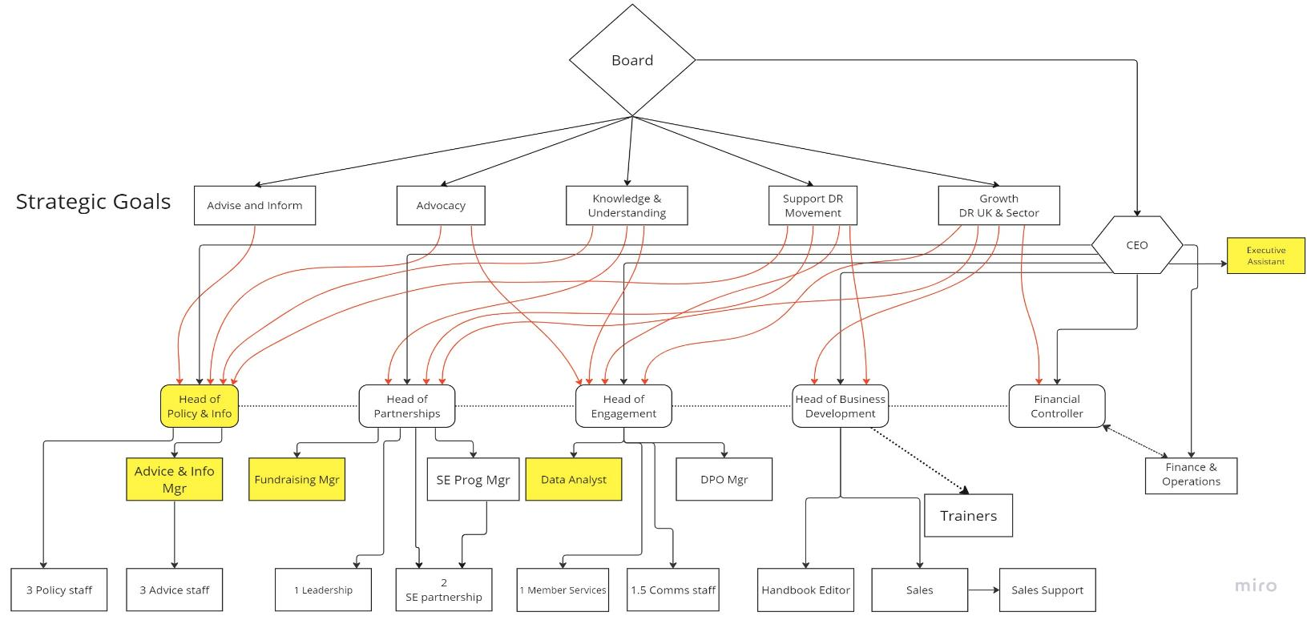
Our Structure
The Role

Executive Assistant

Salary Range: £30,000-32,500
Hours: 35 hours per week, Monday to Friday
Office Base: Disability Rights UK office (London E20), flexible working policy in place
Status: Permanent
Line manager: Chief Executive Officer

Purpose of the role
The Executive Assistant provides flexible, high-quality administrative support to the Chief Executive Officer assisting in managing and directing Disability Rights UK. We need an Executive Assistant who can enable the CEO to lead the organisation to deliver the new strategy.
Key Tasks
Strategic support for CEO
- Manage the CEO’s diary to ensure it continuously reflects current priorities and responds to emerging needs
- Protecting the CEO’s time by prioritising communications
- Support the CEO in preparing for meetings - through both written and verbal briefings. Ensuring that his access requirements are met by external event organisers.
- Provide personal assistance to the CEO including accompanying him to meetings in London and at times across the UK. Supporting his access requirements as a wheelchair user.
- Coordinate Leadership Team meetings, writing agendas, keeping key management documents live and relevant and liaising with the Leadership Team on actions arising.
- Support on the delivery of cross-organisational projects, focusing on topics such as team development; ways of working; culture and values.
- Manage CEO and Leadership Team logistics, including travel arrangements, venue booking and processing expenses.

Internal Communication & Collaboration
- Maintain an accurate organisational calendar, ensuring teams are aware of one another’s capacity across the year.
- Project manage key cross-organisational events, such as conferences and events, ensuring timely input from all relevant team members.
- Develop shared processes & norms to nurture constructive communication with internal & external stakeholders.

Board and Committees
- Manage production of board and committee papers, including support with writing them, and ensuring timely input from the Leadership team.
- Plan and coordinate Board and committee meetings, including supporting the CEO and Chair to set agendas, and ongoing communication with all Trustees.
- Take and distribute Board & Committee minutes and ensure timely follow up on any actions.
- Organise and coordinate Trustee engagement events.
- Arrange the Annual General Meeting.

External Communications
- Manage correspondence between CEO and external stakeholders, including categorising incoming mail, and triaging or delegating to other team members where relevant.
- Ensure a welcoming experience of DR UK for external stakeholders, both for those visiting the office, and those reaching out via email or social media.
- Provide first point of contact for the media at times.

Leadership Team support
- Assisting the Leadership Team, updating the staff leave sheet as well as helping with the induction and onboarding of new staff members.
- Updating policies and processes, to ensure key staff documents are kept up to date - liaise with HR as needed.
- Manage the office, updating the office tracking sheet, ensuring meeting rooms and resources are available, and liaising between team and office staff.
- Supporting organisation wide events including staff training.

Other information
Our CEO, Kamran Mallick, is a wheelchair user. To enable Kamran to carry out his role to the very best of his ability, there are times when he needs support that the EA would provide. Below is an example of what this could mean practically for you:
- Kamran has a meeting in central London at 9 a.m., and he may ask you to meet him either at his home in NW9, our office in London, or the meeting venue. This would depend on his pain levels and what he may need to take with him, such as equipment (eg laptop) and papers. While in the meeting you may be asked to take notes, or you would be able to continue with your own work remotely.
- If meeting him at his home, you would accompany him in a minicab to the venue. You would ensure that his bag, papers, and work phone are kept with him and available as needed. Kamran may need support navigating difficult routes to the meeting and support with physical obstacles such as doors, ramps, etc. If the meeting is over lunch, you may be asked to pick up lunch locally, or there may be a buffet style lunch provided, which he would need support with.

- As CEO, Kamran is often asked to travel out of London to attend conferences and events. You would accompany him, travelling by train/car and providing support as needed. A few times in the year, he would need to travel up the day before and stay overnight. You may required to accompany him on these trips, too.

Please consider this when thinking about applying for the role. If you would like to have a discussion with Kamran to explore this further please get in touch, and we will set this up.

Person Specification
- Personal experience of disability

- Self-direction/autonomous worker - Capacity to take high levels of ownership over your work, anticipating problems that may arise, diagnosing need and changing course quickly; taking initiative within the role to ensure success.

- Ability to learn from others’ expertise - to continually grow your skills, and make a success of tasks at hand.

- Strong communicator - A clear communication style which is concise and effective - both verbally & written - as well as strong interpersonal skills.

- Stakeholder management - Evidence of having established, developed and managed effective relationships with a range of senior stakeholders, both internally and externally.

- Organisation & project management – A track record of coordinating projects to tight timelines and a high standard, communicating proactively if timelines need to shift; as well as sharp attention to detail and thorough approach to organisation and project management.

- Agility in problem-solving – Ability to think creatively/laterally and strategically to find the most effective solution.

- Values – Commitment to the values of Disability Rights UK including the social model of disability and diversity and inclusion.

All of the above will be assessed through the application and the interview process.
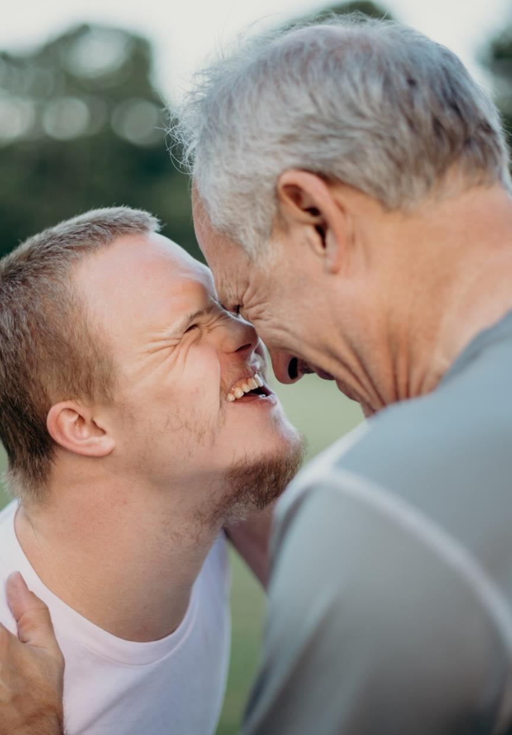
Role Details
This is a full time, permanent role. The salary on offer is between £30,000 - £32,500 depending on track record and experience.

DR UK is based in East London’s Olympic Park, and the role will be a combination of office and remote working. There may be occasional travel and overnight stays as required.

Annual leave entitlement is 25 days plus all public holidays plus 3 days closure between Christmas and New Year.

Benefits include flexible working and a work-based pension with employee contributions of 5% plus employer contributions of 3% from DR UK. DR UK colleagues have access to a website providing discounts at many major retail outlets. We also provide an employee assistance programme.

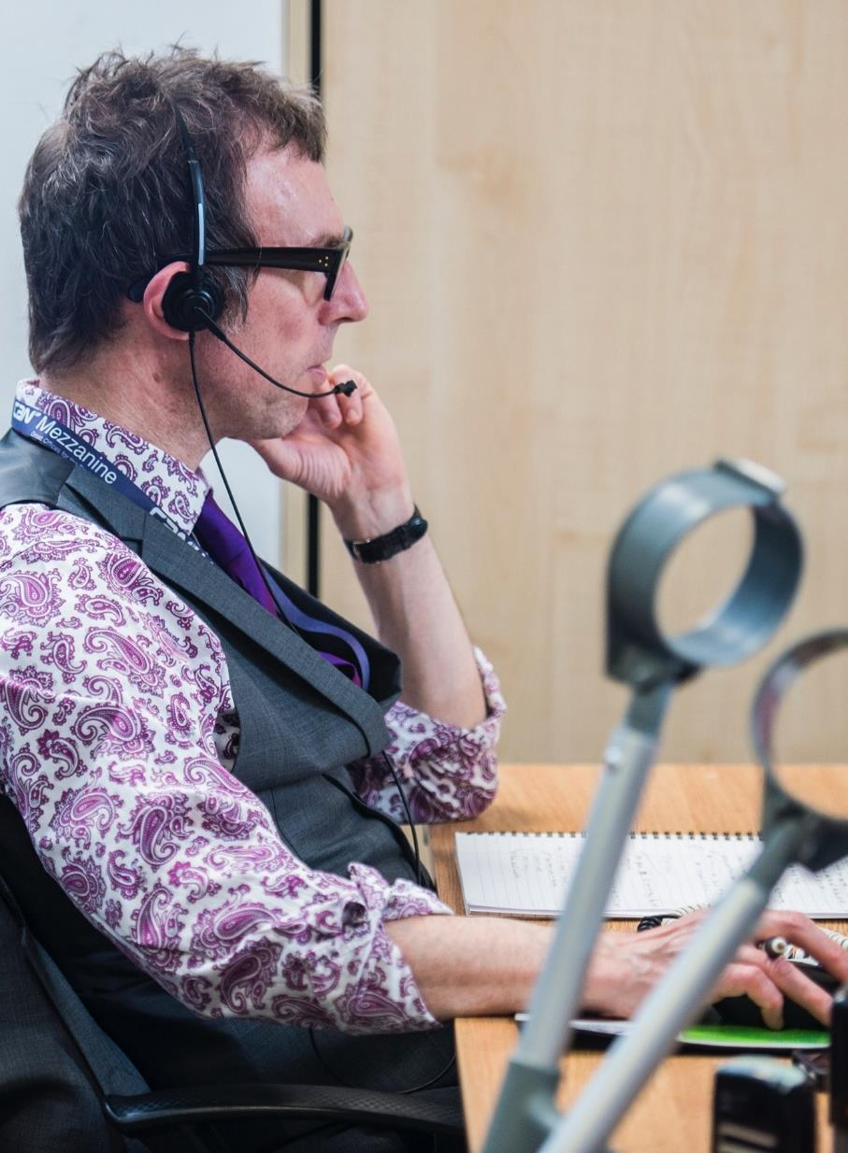
How to Apply
To apply, please send us your CV along with a covering letter to tell us why you want the job and how you meet the requirements outlined in the person specification. Your covering letter can be up to up to 1,000 words in length.

The recruitment for this role will close when we appoint a suitable candidate.

Should you wish to have an informal chat about the role, wish to apply using another format, or need adjustment to enable you to apply, please contact us on 0330 995 0400 or at
recruitment@disabilityrightsuk.org.

Next Steps

- Contact us to have an informal chat about the role
- Send your cover letter and CV to us
- We will interview suitable candidates at a mutually agreeable time
- We will let you know the outcome within a week

We want to see the best of you at every stage of the process. Tell us about any adjustments you need to give you the best experience of this process and to remove barriers at every stage.

Other Information
We acknowledge that people from certain backgrounds are under-represented in our sector, and we’re committed to doing what we can to correct this. We are particularly keen to receive applications from Black, Asian and minority ethnic people; Disabled people; people who identify as being LGBTQIA2S+; people who have a mental health condition; and people who identify as working class now or in the past.

GDPR personal data notice:
As part of any recruitment process, DR UK collects and processes personal data relating to job applicants. In order to carry out the recruitment process we will share the personal data received from you in your application with the shortlisting and interview panel. Access will be restricted to those involved in the recruitment process.

