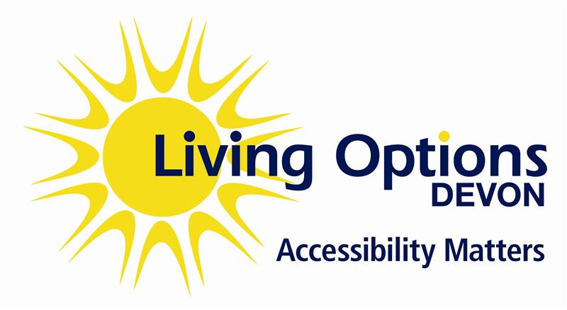

Best practice guidance for the requesting and booking of British Sign Language Interpreters

British Sign Language/English Interpreters:

According to ASLI (Association of Sign Language Interpreters) it is best practice that for meetings of a formal nature such as; hearing, staff meeting (depending on duration), disciplinary, capability, formal procedures, complaints, training, conferences, events, etc. it is strongly recommended that two BSL/English interpreters are to be provided for a meeting that is due to last for more than an hour.

It is also best practice that for any short meetings, such as; supervision, regular team meetings and one to ones, and they are for up to one hour then we recommend one BSL/English Interpreter. Should there be more than four people in any consignment, then please check with the interpreter if they require a coworker.

It can be exhausting for just one interpreter to exert extreme concentration in order to harness the cognitive skills that are required to produce the interpretation in real-time, simultaneously. Interpreting leads to fatigue which can influence the interpreter’s ability to convey information and may lead to information being missed or not heard. This can also depend on the content/complexity of the specific assignment.

Consecutive interpreting is also a helpful strategy that can be used. This means that the interpreter listens to what is being said, or watches what is being signed, and then relays this in BSL or English after the person has finished speaking/signing. This can be helpful particularly if the information is complex, dense, or emotive, and can be easier for people who have learning disabilities to access information in this way.

A fully qualified BSL/English Interpreter (RSLI, yellow badge) and trainee BSL/English Interpreter (TSLI, purple badge) are bound to a Code of Conduct (http://www.nrcpd.org.uk/code-of-conduct) this includes guidance on ethics, professional conduct, and confidentiality. To be registered with the NRCPD, interpreters must have a valid DBS certificate and must have valid Public Indemnity liability insurance. This can be obtained through ASLI membership.

It is important to remember that interpreters are there to aid communication between all parties involved, not solely the Deaf person/people.

Deaf employees who have Access to Work:

- Deaf employees can request and book BSL/English Interpreters themselves. Deaf employees have the right to choose who they want at their meetings.
- Deaf employees can be responsible for booking interpreters for some meetings such as training, supervisions, and office support.
- For other meetings such as hearings and disciplinaries, it is more appropriate for the organisation to book interpreters.
- To avoid disappointment, it is recommended that interpreters are requested 2 to 3 weeks in advance. You should receive confirmation from the interpreter that they have been booked.
- For peace of mind, block booking for meetings throughout the year is an advantage if you know the dates of meetings / events.
- It is imperative that BSL interpreters are given any available notes, presentations or other materials that can help them prepare for assignments. It is part of interpreters’ role to prepare for assignments, and common practise for interpreters to request preparation materials before a booking. This is highly beneficial to aid the interaction during the booking. It will help the interpreters to prepare in advance of assignments if they have access to agendas, names and roles of people involved in an event, previous minutes or other significant details. All materials are dealt with are in the strictest confidence and are only used to assist the accuracy of the interpretation. You are welcome to include a statement when sending preparation, requesting interpreters to delete after use.
Cancellation:
- If an assignment is cancelled, please let the interpreter know as soon as possible. Please check the interpreter’s Terms and Conditions for information about their cancellation fees.
General Deaf people:
Public, private, and voluntary sector have a duty to provide BSL/English Interpreters to aid the communication.

If you need any further information about interpreters, please feel free to look at the ASLI www.asli.org.uk and NRPCD www.nrcpd.org.uk websites.

