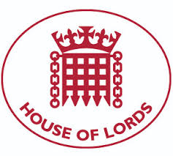
Baroness Campbell of Surbiton DBE
House of Lords
Westminster SW1A 0PW

T: 020 7219 5124
E: janecampbell@btinternet.com

Monday, 06 April 2020

Dear Prof Powis and Ms May
Thank you for your prompt reply to the Covid19 and disabled people, Statement, especially when you reiterated our belief that the NHS should “always seek to fully protect the rights of people with disabilities, now and throughout the course of this global pandemic”. Your words are welcome at a time of great anxiety felt within the disability community.

We will endeavour to keep NHS England abreast of what’s happening on the ground to disabled people throughout the pandemic, to assist with your planning and stand ready to collaborate with any policies and practices that impact on this group.

We will post your response to the statement and the Disability Rights UK website https://disabilityrightsuk.org/news/2020/april/response-open-letter-covid-19-and-rights-disabled-people/ which I am sure will bring relief to those who have received less favourable responses from certain quarters of the medical profession.
Kind regards
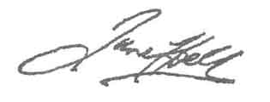
Baroness Campbell of Surbiton DBE

