APPG FOR DISABILITY REPORT ON INQUIRY INTO THE EFFECTS OF BANK BRANCH CLOSURES ON DISABLED PEOPLE

19th April 2018

Summary

- There were a total of 115 responses via a survey carried out on SurveyMonkey.
- The overall responses indicate that most respondees (90%) had been affected by the closure of physical bank branches in their area.
- The closure of physical bank branches has left many disabled people unable to access their banking services without severely increased travel, increased reliance on others, or changing whom they bank with.
- The clear majority of respondees felt that neither mobile bank replacements nor online banking were satisfactory or accessible alternatives (if they had used them).
- Further many respondees made clear that face-to-face interaction with a human was very important to their banking process. Automated and machine-driven processes, which are becoming more and more prevalent, were by and large described as inaccessible to many disabled people, or insufficient in the services they offered.

Question 1 – Has your use of bank services been affected by the closures of physical bank branches?
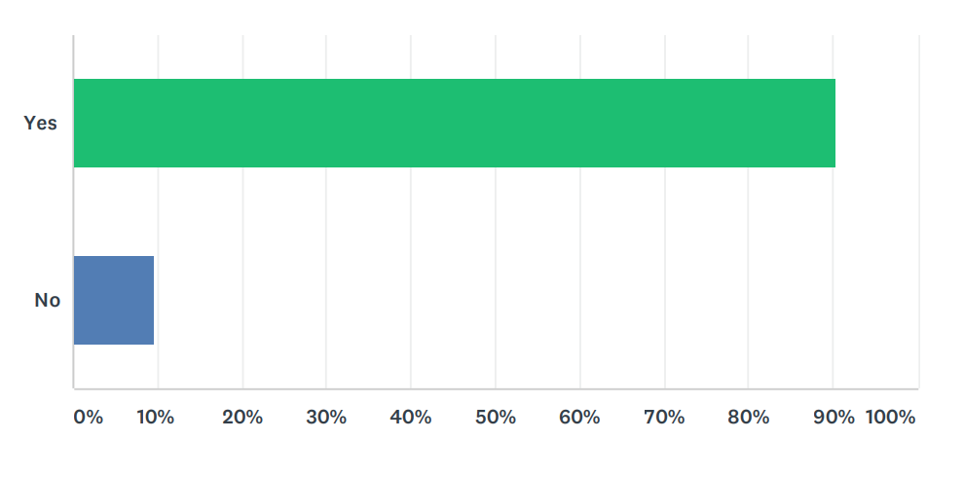
- Almost all respondees to the survey indicated that they had been affected by the closures of physical bank branches in their area, in one way or another.

Question 2 - What would the effects of a closure of your local bank branch be, or what have they been if your local branch has closed?

- By far the biggest detriment reported was a need for increased travel. Some reported now having to travel up to 50 miles to reach their nearest branch after local closures.
- Others reported travel times of 3 hours to reach an accessible branch. Because some disabled people also require disabled access to bank buildings, closure of their local branch does not always entail they can move to the next closest one. Many disabled people also find travel difficult, particularly by public transport. Many reported added distress and discomfort at now having to undertake long public journeys. One respondees said: “[Having] to travel into Falkirk town centre on public transport making things very stressful and exhausting”.
- Adding a need to take transport to the bank also increases costs, and some respondees felt they could not afford such regular fees to access their accounts. One respondee reported: “If I want to access my cash, it involves a long and painful journey, as I cannot afford taxis.”
- Many respondees also cited the loss of face-to-face interaction as a major downside to bank closures. Many felt reassured or confident with their local and known staff, who helped them through processes they found confusing or difficult. Making physical branches harder reach forces customers towards automated services, such as phone and online banking, which are inaccessible for many. One respondee summarised the situation by saying: “The personal touch is very important to me and many others.”
- Loss of independence was also cited as a negative impact of bank closures; some respondees now required the assistance of others to now reach their closest bank branch, which made them feel like a burden. One respondee wrote: “I cannot use a proper branch unless I take myself and wheelchair some 15 miles to the Bullring in Birmingham City Centre. I cannot do this on my own.” Another reported: “My wife has to find time off work to take me [to the bank]".
- Some reported having to change their banking services provider to one that was located nearer, even when they did not really want to. Some were particularly hesitant to change banks because they were not sure for how long their new bank would stay open in their locality.
- Lastly, many respondees felt that the closure of their branch left them feeling isolated from society and their own money. Faced with the possible closure of their local bank, one respondee said that they would simply be unable to reach a physical bank at all, and therefore unable to access these vital services.

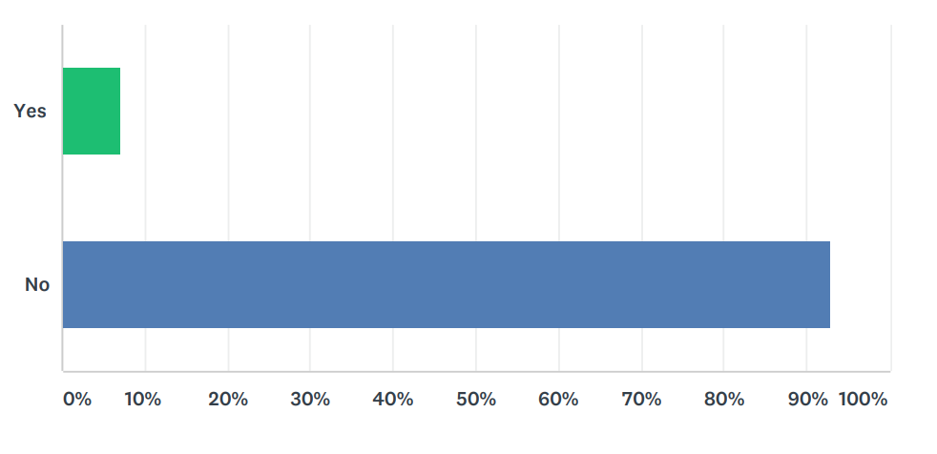
Question 3 - Are online banking services sufficiently accessible and a satisfactory alternative to bank branches?
- The vast majority of respondees were clear that online banking was not an adequate substitute for physical bank branches.
- There were 4 main problems with online banking identified by the respondees.
- Firstly, the services are inaccessible to many disabled and elderly people. In one regard, many elderly and disabled people lack the skills or indeed the internet connection to use such services. Many reported that their specific disability made using online banking difficult. This was particularly the case for those with visual impairments, cognitive or memory impairments, and learning disabilities. The complexity of online banking, the speed with which it must be done (to avoid time outs of the webpage), and the need to remember passwords and “memorable information” make it overwhelming and difficult to navigate for many disabled people.
- Secondly, online banking services, even if they were accessible, are not sufficient replacements for the services of physical banks. They do not allow customers to pay in or withdraw cash, which was reported as a major drawback by several respondees. Other services, such as advice and mortgage and services, were found to be much more appropriate in the setting of a physical branch. Online banking accounts can also be subject to transfer limits, and in many instances customers are prompted to phone-banking, which many also find inaccessible. Disabled people with hearing impairments found this particularly troubling, and others with learning disabilities find phone conversations difficult and stressful.
- Many respondees were also concerned about a lack of human presence – they felt they would be unable to ask for help through online banking and were afraid of making mistakes. One respondee wrote that face-to-face interaction was the “only option” for some disabled people to carry out their banking appropriately.
- Lastly, a great number of respondees were cautious of using online banking for fear that it was dangerous or insecure. Several recalled anecdotal evidence of privacy concerns or issues with fraud in the past.

Question 4 - If you have experience with using mobile bank replacements, were they accessible and satisfactory?
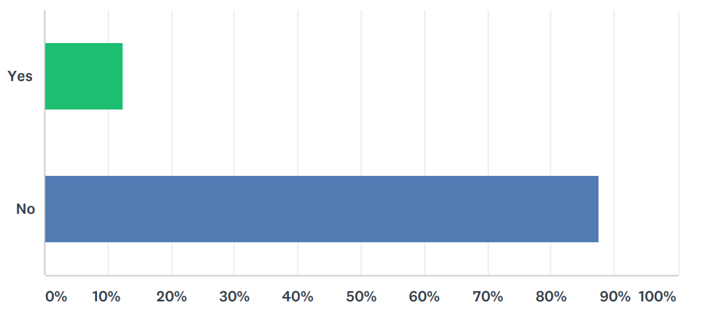

- Only 73 of the 115 respondees answered this question. This indicates that many who have been affected by bank closures had no experience with the mobile replacement units. Several of those who did answer the question similarly noted that they did not know what they were, or that they had never been deployed in their area. One respondee said, referring to the closure of their local branch, that they had “never been given an alternative".
- Those who had used the mobile replacement units reported 2 major problems.
- Firstly, the vans used for this mobile service were frequently inaccessible. They have large steps and some require the individual to “climb in”. The elderly and physically disabled reported that they simply could not get into the van to access the banking services.
- A couple of other respondees also noted that the mobile replacements were simply unsatisfactory in terms of the service provided. One respondee noted that they offered customers no privacy, having to carry out their banking in the middle of a car park and with no shelter from the weather for customers waiting outside. Other respondees reported that the services offered were also “extremely limited”, and that the vans did not stay long enough in each place. Due to long travel times and inconsistent pubic transport in reaching these replacement services, a 1-hour stint in each location was not considered sufficient by some respondees.

Question 5 - What would you like to see done to make bank services more accessible within your community?

- This question was open-ended to allow respondees to contribute ideas and experiences to future policy planning.
- Though the ideas presented were varied, there were 4 main suggestions that were received multiple times.
- The most prominent suggestion was simply to retain physical bank branches, re-open them, or at least offer local bank services through trained bank staff for a specified amount of time per week. The need for face-to-face interaction and reasonable travelling distance meant that this was the first choice for many respondees. Unlike mobile replacements, the suggestions were for the temporary banks to offer full services, and be placed within a shopping centre or supermarket, somewhat similar to many Post Offices.
- Another idea was for banks to co-operate and to create a form of “community bank”, where all major banks were housed in one place. There could be one of these banks in each local area, saving the banks money because they could split the rent and other costs. This would ensure that each major bank was represented with a physical bank presence in every local area.
- More generally, some respondees made the point that certain disabilities are routinely overlooked by the banking industry. This means their services are generally inaccessible for these disabilities, including “hidden” impairments and learning difficulties. According to multiple respondees, these disabilities often make anything other than face-to-face banking an impracticable and stressful experience.
- Lastly, multiple respondees expressed a wish that banks would take the time to inform customers – particularly disabled customers – when changes to the service are upcoming. With adequate warning, at least some of the negative impacts of branch closures may be mitigated. Some were not informed of the closure of their bank with sufficient notice to make other arrangements, and were left for some time without access to their accounts.

Conclusion

- In the round, the inquiry demonstrates that the closure of physical bank branches is having a detrimental effect on the lives of disabled people.
- The alternatives to physical bank branches, online banking and mobile bank replacements, are widely considered inaccessible and insufficient in the services they offer to disabled people.
- Many disabled people who wish to still visit a physical bank branch – to access the full range of services – must travel long distances to find one which is accessible. This is very difficult for many, and impossible for others, who had to change banks after branch closures.
- Many disabled people stated a clear need for face-to-face interaction in their banking services, which is not delivered by the increasingly automated systems offered by banks.
- The closures are resulting in some disabled people losing their sense of independence, as they now cannot complete their banking by themselves, and others have been left feeling isolated from society.

