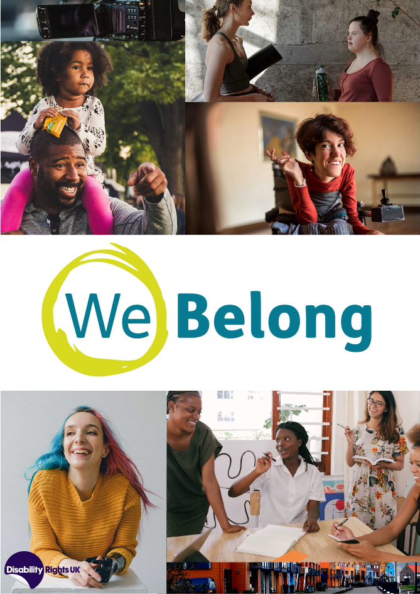

Foreword
In the autumn of 2020, Disability Rights UK launched a new campaign – We Belong.

From September to November, we gathered the opinions of disabled people from across the country, young and old, from all kinds of backgrounds.

We sought comment through our newsletters, social media, email and phone, and virtual meetings. We ran Zoom meetings on transport, employment, the built environment, housing, participation, services and retail.

We held discussions with groups of disabled people experiencing multiple forms of discrimination including people from BAME backgrounds, women, LGBTQIA* people, young people and children. We also hosted a discussion for parents of disabled children and young people.

We heard from a wide cross-section of disabled people. What you will read below is a summary of how society needs to change, based on the thoughts, feelings and experiences of disabled people on the state of this nation and how it recognises, treats, protects and empowers us.

Disabled people make up a fifth of our population. We are not invisible. And yet we are too often overlooked. We are the largest minority that faces discrimination in this country. We are the forgotten majority.

Society must change how it views and includes us. It is time for everyone to recognise and acknowledge that We Belong.

We Belong in society.

We Belong in the workforce.

We Belong in our neighbourhoods.

We Belong in our towns, villages and cities.

We Belong in our schools, colleges and universities. We Belong on public transport.
We Belong in our shops. We Belong in our cinemas.

We Belong in our parks.

We Belong in our leisure facilities.

We Belong in our woods, in our fields and on our beaches.

We Belong to a country that deserves to have the richness of its diversity reflected in it through our belonging to all of these places.

We Belong to learn, qualify and excel. We Belong to share our skills, our experiences and our expertise. We Belong to share our wisdom, intelligence and worth.

This campaign has helped us identify what still needs to change. It is a call to society to recognise us as equal to non-disabled people – not pity cases, not people who can be ignored, not an inconvenience.

I would like to thank all of you who contributed. Your thoughts and opinions matter and they will be heard.

The government is publishing a new National Strategy for Disabled People in 2021. We will share the comments of all who contributed to this project with the government, so it hears the views expressed.

We ask the government to take bold and radical action to tackle the systemic discrimination and inequality which persist, and to produce an ambitious groundbreaking Strategy, which creates a society where we truly Belong.

Kamran Mallick
CEO Disability Rights UK

About this report
This report sets out key recommendations for the National Strategy for Disabled People.

These recommendations were developed after hearing the views of hundreds of disabled people and organisations.

We have divided the report into five sections. All recommendations are listed at the start of this document.

Foundations: radical change to rights, voice and participation
- Independence: enabling support, choice and control
- Inclusion: removing societal barriers
- Attitudes: changing perceptions
- Protections: outlawing crimes

For more on the We Belong project, go to: we-belong.co.uk.

Foundations
  - Extend and enforce the Equality Act
  - Incorporate the UNCRPD into UK law
  - Implement a strategy to fund Disabled People’s Led Organisations (DPOs) across all areas
  - Develop co-production and engagement with DPOs at national and local levels, across all policy and service areas
  - Establish a permanent fund to support the reasonable adjustments required by disabled people standing for election
  - Improve disability data collection, including impairment-specific data, to reveal the true level of inequality.

Independence
  - Reform the benefits system, to ensure payment levels meet the costs of disability and that processes support wellbeing, respect and dignity
  - Develop a social care system, with appropriate funding, that enables disabled people of all ages to live with dignity, choice and control, and with connection to family and community
  - Introduce targeted impairment-specific employment programmes to support disabled people into work
  - Provide families with disabled children with a key worker/advocate, to coordinate support services
  - Provide support for disabled parents, to enable them to play a full parenting role.

Inclusion
  - Support local social infrastructure, which enables connection and participation, including libraries, community spaces and support facilities such as day centres
  - Introduce mandatory reporting of the number of disabled people employed, satisfaction levels, and the pay gap
  - Increase the pace of change to public transport, to enable and improve passenger journeys
  - Develop policies to ensure that public spaces and the built environment are accessible
  - Require Local Authorities to set out plans to meet the accessible housing needs of disabled citizens
  - Make all new build homes accessible to disabled people, with a minimum percentage built to meet the needs of wheelchair users

  - Require all essential services including supermarkets to record the specific communication and support needs of disabled customers.

Attitudes
  - Deliver a public awareness campaign based on the Social Model of Disability
  - Incorporate disability equality and the Social Model into the school curriculum, and teacher training
  - Increase the visibility of disabled people across all media channels including TV, press and digital.

Protections
  - Improve support to disabled people experiencing domestic abuse
  - Strengthen laws on disability hate crime.

Extend and enforce the Equality Act
The Equality Act needs to be extended and made to be easier to enforce. The Equality Act should be extended to cover the inclusive design of manufactured goods including technology products. It should enable direct enforcement of provisions by the Equality and Human Rights Commission and public bodies. It should not be left to individual disabled people to uphold the provisions of the Act. Where disabled people do uphold rights under the Act relating to employment and services, we should be financially supported, and processes should be simple to administer.

Incorporate the UNCRPD into UK law
Whilst the Equality Act has valuable provisions such as the duty to make reasonable adjustments, it does not provide a framework to change societal values, direction, systems and attitudes to fully include disabled people as equal citizens. Incorporating the United Nations Convention on the Rights of Persons with Disabilities would provide the basis for societal re-design to better include disabled people.

Implement a strategy to fund Disabled People’s Led Organisations (DPOs) across all areas
To enable disabled people to participate in co-production and engagement at national and local levels, and to ensure that specific services support the independence of disabled people, a network of funded DPOs across the country is needed. These bodies would work with national and local government, health bodies, the voluntary sector and private organisations, to ensure the needs of disabled people are met. They would also deliver a range of services such as information and advice, support for direct payments, social prescribing, sport and fitness, and employment support. The government should make it a requirement for every area to have a DPO and ensure the relevant funding.

Develop co-production and engagement with DPOs at national and local levels, across all policy and service areas
In line with Article 4 of the UNCRPD, the government should pro-actively engage in co- production with DPOs. Co-production could have prevented many of the issues disabled people have faced during the COVID-19 pandemic, as many government decisions were made without sufficient consideration of their impact on disabled people. Co-production must be properly supported. Organisations and individuals must be paid for their time and expertise when engaging in co-production with public bodies. Co-production must also be meaningful, in-depth and seek to engage as many people and organisations, as can contribute. When designing or reviewing policies and programmes, there should be co-production from the outset, so that it can genuinely influence outcomes.

Establish a permanent fund, to support the reasonable adjustments required by disabled people standing for election
The under-representation of disabled people holding political office is truly shocking. The EnAble Fund and the prior Access to Elected Office Fund have been highly effective in enabling disabled people of all persuasions to run for elected office. The funding has enabled disabled candidates to meet the costs of reasonable adjustments. If government wants to seek reimbursement from political parties, this is their jurisdiction, but disabled people should not be involved in these arrangements. This would mirror the principles of Access to Work. The government should report on the number of disabled people holding all forms of elected office.

Improve disability data collection, including impairment-specific data, to reveal the true level of inequality
Disabled people are often not identified in official statistics or administrative data, and impairment-specific data is rare or non-existent. Better data will enable the identification of systemic issues and consequent solutions. Where disability data is collected, other relevant and intersectional data often is not. For example, the DWP does not record the ethnicity of applicants for disability benefits, making it impossible to identify any inequalities in assessment outcomes. Improved data is required to enhance knowledge and monitor the effects of policies on disabled people.

Reform the benefits system to ensure payment levels meet the costs of disability and that processes support wellbeing, respect and dignity
We need to ensure that the level of benefits reflects the actual cost of living with a disability, allowing individuals to thrive, not just survive. The culture of conditionality, sanctions and distrust needs to be abandoned. Instead, there should be a system that enables dignity and independence. The level of disability payments should be re- assessed frequently, to enable all essential costs to be met, removing the need for visits to food banks. The benefit rates should increase annually in line with the state pension increase.

Develop a social care system with appropriate funding that enables disabled people of all ages to live with dignity, choice and control, and with connection to family and community
Social care reform needs to uphold the principles of enabling independence and connection, as well as injecting increased funding into the system. A new settlement for social care should be based on providing disabled people of all ages with the personalised support we need to lead our best lives. There should be an assumption that people want to live within the community rather than default to institutional settings. There need to be funded transformation plans which support disabled people to move out of institutions and into community provision.

Introduce targeted impairment-specific employment programmes
The employment of disabled people has been negatively affected by the pandemic. The government is committed to getting an additional one million disabled people into work by 2027. Generic employment programmes aren’t enough to support disabled people into work. A much more targeted approach is needed which understands the different types of support required by disabled people and the barriers to inclusion that need to be removed.

Provide families with disabled children with a key worker/advocate to co-ordinate support services
A key worker that supports the parents of disabled children and young people to
co-ordinate education, care, health and therapies would have a transformative effect on parents’ lives and improve the quality of support that families receive. This would help all parents, but particularly those who struggle with the complexity of jargon and services. Also, language and processes need to be simplified, to make them as accessible as possible, removing the administrative burden from families.

Provide support for disabled parents to enable them to play a full parenting role
Support for disabled parents was described as being judgemental, intrusive and damaging to both parents and children. Many disabled parents fear losing their children if they engage with support services, and as a consequence stay away from such services. The social care system needs to review how it supports disabled parents to ensure specific support for meeting parental responsibilities.

Support local social infrastructure, which enables connection and participation, including libraries, community spaces and supported facilities such as day centres
Social infrastructure is vital to reducing loneliness, fostering community, and creating DPOs and other civil society groups. Places where people can congregate and socialise free of charge, exercise, work and simply get out of the house are vital to any inclusive and fair society. Disabled people should be supported to use social infrastructure, including at day centres and other supported facilities, as well as non- supported facilities.

Introduce mandatory reporting of the number of disabled people employed, satisfaction levels, and the pay gap
There should be mandatory reporting by employers of the number of disabled employees, their satisfaction levels, and the disability pay gap between disabled and non-disabled employees. Disability Confident employers should report on a range of indicators including numbers employed, career progression, harassment, redundancy, satisfaction levels, and the pay gap.

Increase the pace of change to public transport, to enable and improve passenger journeys
National and local government and transport organisations should co-produce changes and improvements to transport with Disabled People’s Organisations. Stations, platforms, trains and ticketing systems must all be made accessible at a more rapid pace. The UK’s decentralised bus services, which are relied on by millions of older and disabled people, require massive improvements to enable affordability, frequency and accessibility, and must be reformed. Personalised human support from rail staff and bus drivers is essential to enable disabled people to travel. Staff training, understanding and awareness must be improved.

Develop policies to ensure that public spaces and the built environment are accessible
Disabled people face a wide range of barriers in the public built environment, resulting from accessibility being an afterthought. Working with Disabled People’s Organisations to ensure infrastructure is accessible to all would have a transformative and positive effect on the built environment, creating streets that are liveable and safe for all, allowing for full participation in society. There must also be more available options for mobility equipment, to enable disabled people to go out and about. Government- backed schemes to make renting or borrowing specialised mobility vehicles would make it possible for more disabled people to access the built environment, as well as the natural environment.

Require Local Authorities to set out plans to meet the accessible housing needs of disabled citizens
Many Local Authorities have an inadequate range of housing available to disabled people and fail to plan for the housing needs of their citizens. The current housing stock is not appropriate for the needs of disabled people or the growing population of older people. Housing is a major determinant of quality of life and good health, and much more needs to be done across all tenures, to ensure that it meets the varied needs of disabled citizens. The national government should set an inclusive direction for housing, and the local government should plan for a diversity of provision that meets population requirements.

Make all new build homes accessible to disabled people, with a minimum percentage built to meet the needs of wheelchair users
All new homes should be built to M4(2) – Accessible and Adaptable Homes Standard, with a minimum percentage, say 10%, built to M4(3) for wheelchair users. This would ensure that new homes meet the needs of existing and future disabled people.
Adopting these standards would establish a level playing field across developers, builders and Local Authorities. The national government needs to put these standards in place.

Require all essential services including supermarkets to record the specific communication and support needs of disabled customers
The COVID-19 pandemic has highlighted systemic inequalities in access to essential supplies such as food and medicine. There needs to be action taken to ensure that disabled people receive basic services. Establishing customer priority registers is common for utility sector suppliers (gas, electricity and water suppliers) and should now be required by other key sectors such as supermarkets.

Deliver a public awareness campaign based on the Social Model of Disability
Many of the barriers and issues that disabled people face in daily life stem from a lack of understanding from service providers, employers and individuals. A co-produced public awareness campaign grounded in the Social Model of Disability would help to frame disability within its societal context and to challenge negative assumptions and misconceptions. The campaign also needs to recognise the intersectional discriminations faced by disabled people. Resources need to be designed and tailored to reach and positively influence diverse communities.

Incorporate disability equality and the Social Model into the school curriculum and teacher training
Disabled school pupils still experience significant discrimination and harassment within the school system. There is an urgent need to create school environments, which are inclusive of all pupils. Improving the promotion of disability understanding and awareness within our schools could lead over time to a wider shift in societal attitudes and culture. Modules on disability and disabled people should be incorporated into the Personal, Social, Health and Economic (PSHE) education curriculum. Teachers and teaching assistants need training to better understand the Social Model of Disability, to enable them to provide empowering support, reasonable adjustments and inclusive classrooms.

Increase the visibility of disabled people across all media channels including TV, press and digital
There is a widespread under-representation of disabled people in popular media. When disabled people are in the media, for example in news programmes, our contributions often focus on disability issues. Increasing the number of disabled people working behind the scenes and on TV would transform programming and enable

disabled people to be more visible. We urge government and media organisations to set challenging targets for disability inclusion.

Improve support to disabled people experiencing domestic abuse
Disabled women are disproportionately more likely to be survivors of domestic abuse. Abuse can be experienced by partners, family members and paid and unpaid carers. We can have our impairments used against us. Domestic abuse services are often inaccessible, and unable to provide specific support. There needs to be a better response to disabled people experiencing domestic abuse from police and other support agencies. Refuge and related advice and support services need to be capable of meeting practical, emotional and accessibility needs. The government needs to improve support and protection services for disabled people experiencing domestic abuse.

Strengthen laws on disability hate crime
Disability hate crime remains poorly understood by government, police and lawyers. Disabled people are targeted because of our impairments and we often don’t report the incidents we experience. The penalties for disability hate crime need to be more severe, and disabled people need to be convinced that it is worth reporting crimes.
Police and those involved in the legal system, along with social care and housing staff, need to be trained to recognise and respond to disability hate crime.

