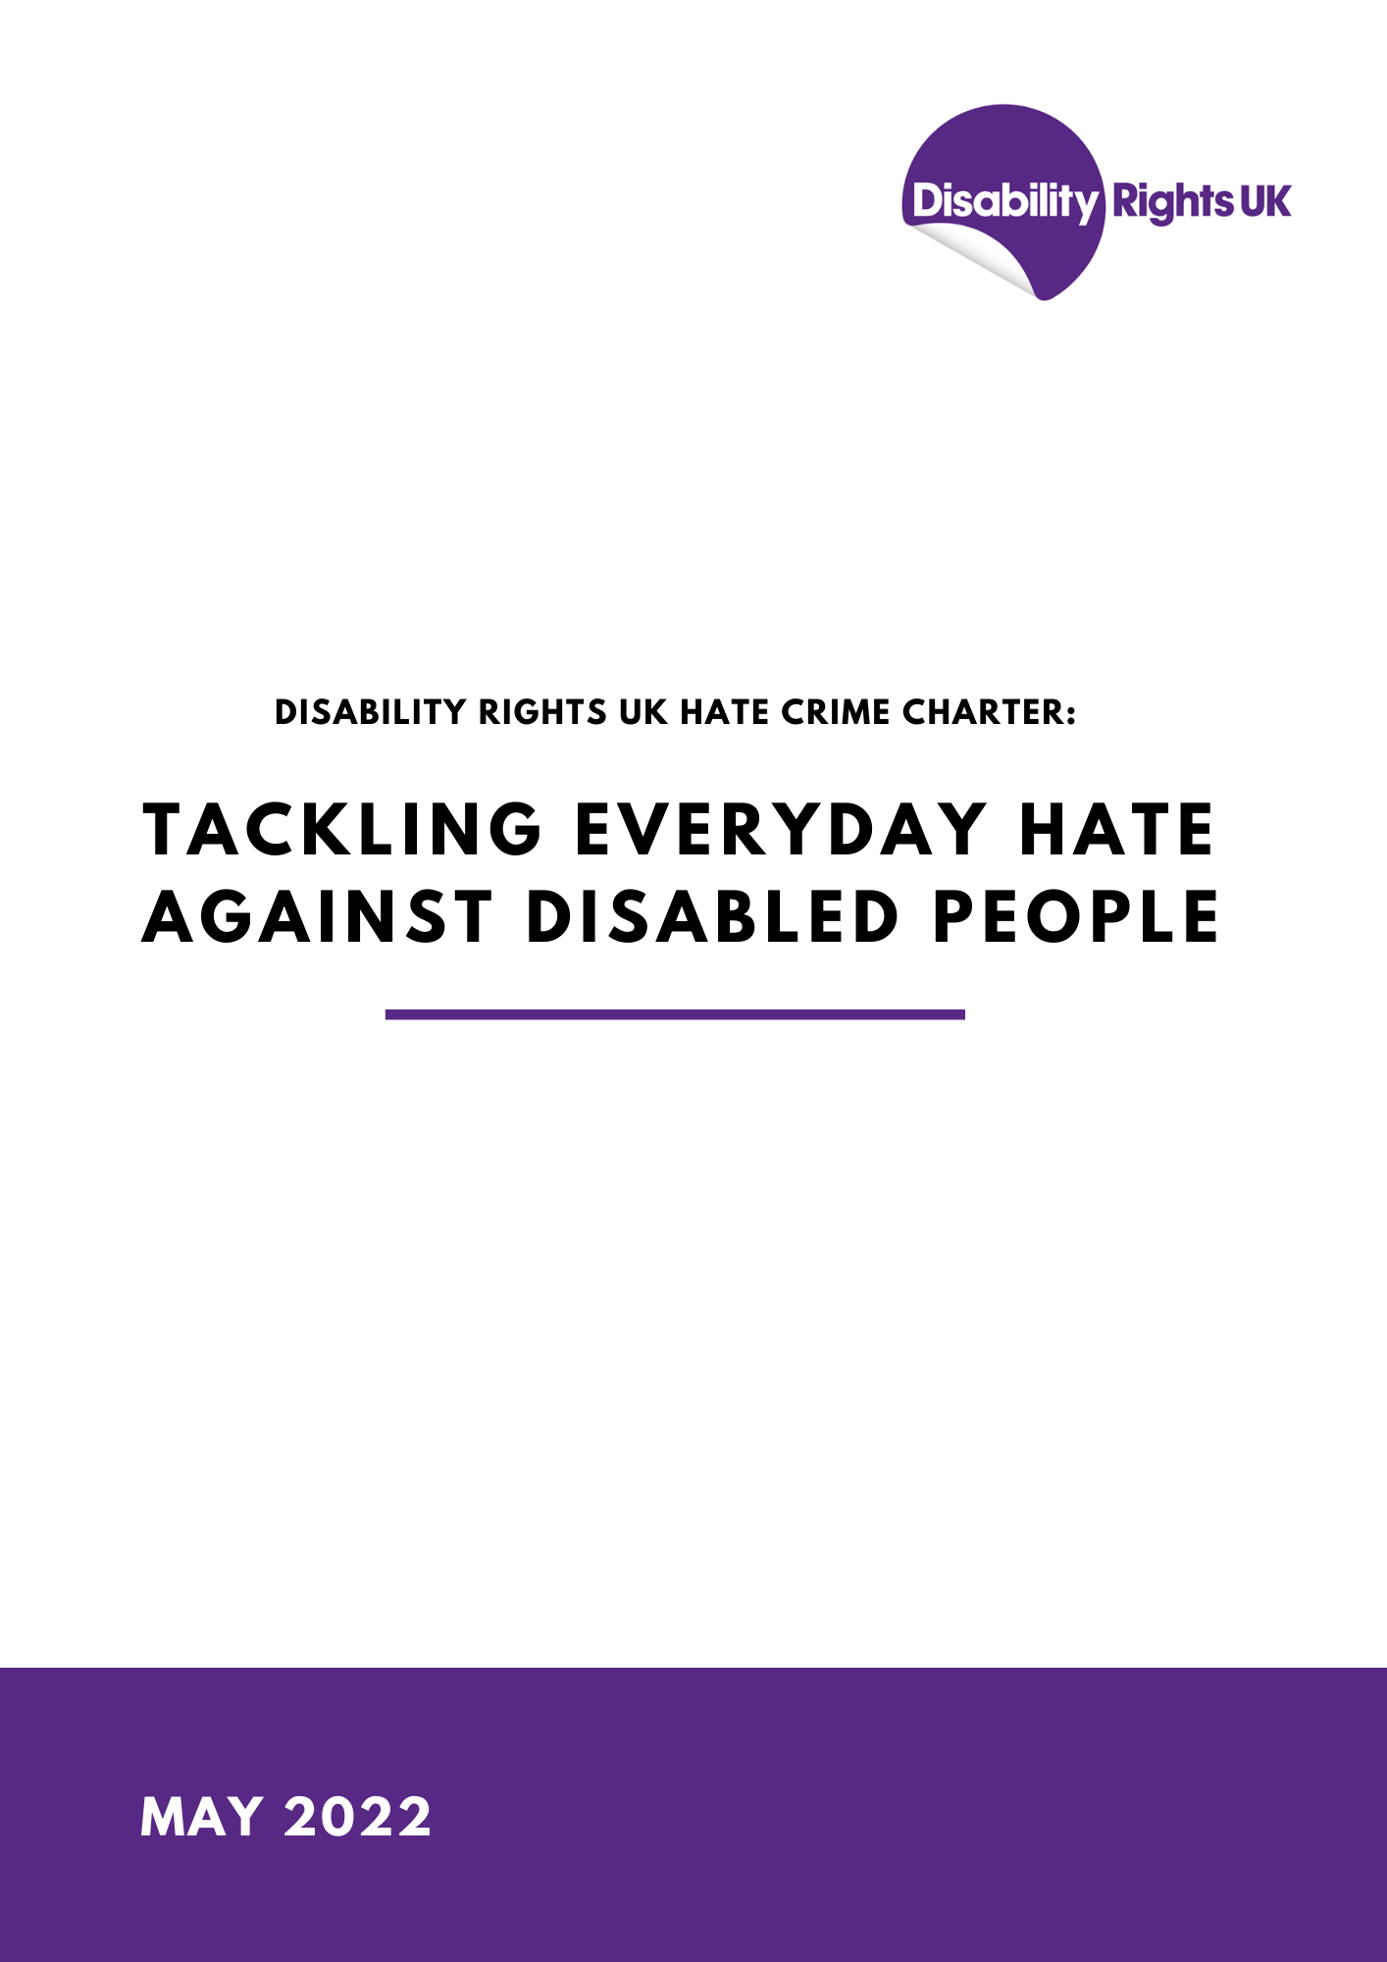

Disability Rights UK Hate Crime Charter:
Tackling everyday hate against Disabled people

“Disability is always at the end and by the time anyone gets around to discussing it, everybody’s so cheesed off, fed up and ready to go home, it’s the last thing on the agenda” – Disability Hate Crime Victim
Context
Victims of disability hate crime (DHC) are currently being failed at every stage by the Criminal Justice System in England from reporting to prosecution. Victims have shared that it’s unclear where they should go to report, there’s a consistent lack of support throughout the process, and institutional ableism places additional barriers when trying to deal with authorities like the Police.
The Home Office reports that between 2015/16 and 2020/21, disability hate crimes recorded by the police increased from 3,393 to 9,280, a rise of 173.5%. Yet over the same period, the number of cases sent to the Crown Prosecution Service (CPS) fell from 895 to 298, a fall of 66.7%. This dramatic rise in hate crime, alongside the disparity between reports and prosecutions is deeply concerning.
In addition to the barriers to reporting and prosecuting, minimal resources are being provided to tackle the issue – and where resources are allocated, it is insufficient. DHC cases are more complex and time-consuming, yet they’re the most consistently under-resourced and de-prioritised. For example, victims of DHC are often more consistently victimised than other groups, the victim’s safety can be impacted by benefit delays and reduced access to support, and cases often take longer as Disabled victims are less likely to be believed or taken seriously.
This charter, written in collaboration with Disabled people and other experts in the field, sets out the urgent action required to give Disabled people confidence in the response to disability hate crime. We hope that this charter unifies the voice of Disabled people, empowers DHC victims in understanding their entitlement to support and justice, while also making institutions accountable on what action they should be delivering.

SECTION 1 - OUR RIGHTS

“No-one [is] reporting it because that’s what you get your whole life, and you don’t know any different” – Disability Hate Crime Victim

Disabled people make up a fifth of the population. We are the largest minority group facing discrimination in this country.
Victims of disability hate crime are not only impacted at the time of the event but continue to be affected throughout their lives. Cumbria PCC research identified many long-term impacts of hate crime, including (but not limited to) anxiety, a distrust towards others, and a fear of going outside. Just under 50% of hate crime victims said they avoid going to certain places for fear that they may be victimised again. Many disabled people report long-term impacts on how they feel about themselves and their place within society. This can cause people to feel out of place and therefore become increasingly isolated.
The guiding principles of the United Nations Convention on the Rights of People with Disabilities (UNCRPD) includes: “Respect for inherent dignity”, “Non-discrimination”, “Full and effective inclusion in society” and “Respect for difference and acceptance of persons with disabilities”. The current treatment of disability hate crime victims by all institutions involved in the processes from reporting to prosecuting are too often failing to meet this international legal obligation. They also often fail to meet their Public Sector Equality Duty, as outlined in the Equality Act 2010. This charter sets out the steps that need to be taken for Disabled people to finally enjoy the same protections as their non-Disabled peers and feel safe participating in society.
Disabled people have a right to life – this includes the right to live free from hate. The right get around without harassment, the right to go to school without being bullied, and the right to live without fear of animosity from others. When this right is not upheld, we deserve to feel confident in reporting and require support, understanding and action from those who we choose to report to.

SECTION 2 – YOUR RESPONSIBILITY

The following outlines how institutions can begin to truly address disability hate crime and give victims justice.

"The first barrier that you need to overcome is being believed.
It's all very well having [been] promised justice, but if you're not believed when reporting a crime, it ends there!" – Disability Hate Crime Victim

Central Government
- Make disability hate crime a criminal offence.
DHC victims are not currently sufficiently protected under the law and the inconsistency in legislation between racially/religiously motivated hate crimes and DHC causes confusion. In 2021, the Law Commission recommended that the protection of Disabled victims be ‘levelled up’, to bring it in line with hate crime laws that offer greater protection for other groups. As the Commission highlighted in their report, there should be no ‘hierarchy of protection’. This not only complicates matters, but it also implies that the protection of Disabled victims is less important.

- Fund local services.
Funding is needed to resource services required to prevent hate crime and support victims. The below recommendations for institutions all require funding from central government, including sufficient funding for disability specialist third-party reporting centres. It’s essential when allocating funding that the Government accommodates the additional resources needed to tackle DHC cases, due to the increased complexity of cases. Long-term funding is needed for specialised disability victim support, as currently they are forced to take on less clients due to extra time and resources it takes to carry out DHC cases.

- Increase transparency.
Detailed data on disability hate crime must be collected and made publicly available, and there must be greater transparency across institutions on how they’re dealing with the issue.

“What’s the point of reporting this because no-one will take it seriously”
– Disability Hate Crime Victim

Police

- Improve clarity of reporting routes, and increase promotion, so that victims are aware of where to go.

- Prioritise crimes motivated by hostility and aggression towards Disabled people and secure evidence to enable a successful prosecution.
Many disabled people who have reported hate crimes have found this process re-traumatizing. Given the low prosecution rates of DHC, many victims believe that the emotional risks outweigh the small chance of a successful prosecution.³ It’s vital that police believe victims and prioritise DHC investigations.

- Improve practical and emotional support to victims to enable them to pursue their case.
The accounts of victims must be believed, and their cases need prioritising. There should be consistent support provided to victims throughout the process of reporting, including resourcing third-party reporting centres and creating specialist DHC teams – much like the departments that exist for domestic abuse victims.

- Improve communication between forces of police.
While improving clarity on reporting routes, it’s essential that there is effective communication between all police forces – especially between the BTP and other forces - to ensure no victims slip through the cracks or keep being signposted to different forces until they eventually give up.

- Tackle institutional ableism within the Police.
Provide Disabled-led training on how to support DHC victims, implement greater accountability regarding hostility towards victims by police - including disciplinary action for officers who exhibit ableist behaviour and attitudes in any circumstance.

- Instigate prosecutions against police officers that are dismissed for gross misconduct against Disabled people.
Research has shown that Disabled people have the lowest levels of confidence in the Metropolitan Police than any other demographic and that this is usually due to having faced discriminatory behaviour or having not been taken seriously by police officers.⁴

- Research into why so many DHC reports are dismissed before prosecution and immediately follow up action.
The police must take active steps to ensure prosecutions are taken.

“What I’ve noticed with police is if you end up in a really distressing situation like that, they don’t understand the impact of that trauma, the distress. So, they see the distress and they think you’re just a bit out of control.” – Disability Hate Crime Victim

“I’m experiencing the hate, that person looks at me and intimidates me and that is my experience that I shouldn’t have to tolerate in my day-to-day life. I shouldn’t have to deal with men laughing at me in the pub, or someone staring at me with disgust or hate, but these are everyday experiences that I have”
– Disability Hate Crime Victim

CPS
- Take steps as a matter of urgency to ensure quality casework and positive outcomes.

- Effectively support, inform, and engage victims of DHC throughout the legal process.

- Work on a multi-agency basis to ensure Disabled victims receive joined-up support.

- Improve communication to Disabled people and Disabled people’s organisations, on the factors which contribute to a successful legal case.

Her Majesty's Courts and Tribunals Service
- Ensure reasonable adjustments are put in place to support all Disabled users of court services.

- Improve the accessibility of the courts service in respect of its processes, buildings and its communication and information services.

- Increase understanding amongst Disabled people and Disabled people’s organisations of how the courts work and where support can be accessed.

“He said that prams should have priority and we were a pain because we were so useless. We had a meeting with the manager at the bus garage because of all the abuse we were getting, and the staff didn’t help. But I knew that he told his drivers that babies in prams were more important than ‘spacco’s in wheelchairs’”
– Disability Hate Crime Victim

"If life wasn't difficult enough, with planning your journey, having to hump your equipment, relying on an iffy service ... and then we have to get abused for the privilege of being disabled.” – Disability Hate Crime Victim

Transport Providers
- Provide and promote easy routes to complain about hate crime and antisocial behaviour on transport.
Transport providers must build an awareness of the rights of victims and the consequences of anti-social behaviour and abuse towards transport users. Clear signposting and communication of reporting routes and what hate crime is, is essential for victims to know where to go and for perpetrators to see that their actions are unacceptable. Scottish rail services are already proactively improving their communication in this area, with their Hate Crime Charter Campaign.

- Identify the causes of hate crime and antisocial behaviour on transport and take immediate action.
Disabled people are more likely to be victimised on transport, as transit is a vulnerable space and Disabled individuals are often targeted for taking up a priority seat or appearing to have paid less or nothing for their travel. Disabled individuals with invisible impairments also feel more at risk of being challenged when occupying accessible spaces on public transport.³

- Communicate clear standards for behaviour expected on public transport by all passengers.
Research by the University of Leicester found that violence on transport often consists of passengers preventing Disabled people from occupying priority spaces and seating, as well as jostling, pushing, threatening language, verbal attacks, and psychological abuse. In an overwhelming proportion of incidents, victims felt unwilling or unable to retaliate. It's essential that transport providers deliver inclusive transport for all.

- Provide transport Staff with training on how to prevent hate crime and how to support victims and tackle hate crime when it occurs.
University of Leicester research found that when DHC victims asked staff to intervene during incidents, staff were only helpful in 2% of incidents. 84% were met with indifference, ignorance, or an inability to help, whilst in 8% of occurrences staff were the abusers – either alone or with others.⁵
Transport staff must be trained on not disregarding DHC, how to prevent anti-social behaviour and abuse targeted at Disabled transport users, and how to best support victims.

“He looked at me and started dribbling. He had clearly seen me dribble, but I can’t help myself. He winked at me. He knew what he was doing. He was making me feel like a psycho. I asked if anyone could help me to get to the door—I have never seen so many heads turn toward windows. It was like synchronised swimmers all acting at once. I wouldn’t have said that this a hate incident, but someone said, ‘they get paid enough [referring to welfare benefits], they can stand’. I politely asked for the seat and was told ‘cripples at the back’” – Disability Hate Crime Victim

Local Authorities
- Promote awareness of a zero-tolerance of disability hate crime among local citizens and communicate ways of reporting hate crime and sources of support for victims.
As outlined in previous institution recommendations – it’s essential that at every step, DHC victims know what reporting options they have and where they can go for support. Due to the large overlap between anti-social behaviour and hate crime, it’s also vital that local authorities are raising awareness of what hate crime is and what behaviour is unacceptable within their communities.

- In compliance with the Equality Act 2010 – particularly the Public Sector Equality Duty - explicitly implement plans to respond to disability hate crime across all service areas.
Local authorities often end up being the institutions left to support and advocate for victims when the police refuse to help. It’s essential that they have a clearly defined plan for tackling DHC in their area, as part of their usual equality duties. All local authorities should enforce their Public Sector Equality Duty by creating and implementing a clear DHC response.

- Commission and fund Disabled people’s organisations and other voluntary services, to support victims of disability hate crime - recognising that this support needs to be highly personalised.
As previously mentioned, tackling DHC requires more time and resources than other hate crimes as various additional barriers make cases more complex. It’s imperative that local services currently providing support for DHC victims are sufficiently funded and resourced for the work that they’re doing.

- Provide training to all local authority employees and contractors, including those in public-facing roles, to tackle disability hate crime and support Disabled victims. This should be led by Disabled trainers.

Schools, Further Education and Higher Education
- Communicate a zero-tolerance approach to bullying and harassment and put clear processes in place for reporting and tackling Disability Hate crime and supporting Disabled victims.
Early identification and intervention of students who are bullying others could help prevent future hate crime incidents post-education. Bullying and harassment in school motivated by ableism is no different to ableist anti-social behaviour that leads to hate crime in the community. Schools must intervene in cases of bullying and harassment and ensure that victims are supported.

- Build awareness of hate crime through the curriculum and other activities.
Education regarding what DHC is and the consequences of anti-social behaviour is necessary across all education settings. Disabled students should be made aware of their rights so that they can have confidence in what to do when those rights are breeched. Students should also be made aware of the consequences of hate crime, both for perpetrators and victims.

Care providers
- Communicate a zero-tolerance of harassment and discrimination. Put clear processes in place for reporting disability hate crime and supporting Disabled victims.
A clear process must be outlined and promoted on how DHC victims can report their experience and access support. Whistleblowing policies for staff and visitors on how to report on behalf of a care user must also be clearly outlined.

- Provide training for staff on how to tackle disability hate crime and support Disabled victims in care homes and residential schools.
Staff must be trained on how to identify and prevent DHC from taking place in care settings. All staff must be made aware of what DHC is and how to best support victims of DHC incidents.

- Create an inclusive environment within residential and community care.
Increase transparency regarding safeguarding measures and the treatment of care users by care staff.

“Every day, twice a day, I used the tram.
My friend, my carer, my so-called friend… was the very person
who reduced me to uselessness. She told everyone how much benefit I got,
how filthy I was to clean and how she never got any sleep.
I always looked at the floor because others were judging me.”
– Disability Hate Crime Victim

Housing Associations
- Tackle anti-social behaviour and support those victimised by it.
Perceived low-level crimes like anti-social behaviour targeted towards Disabled people are hugely impactful. They can leave victims afraid to leave their house, changing their route home, and stop them from attending things like medical appointments or seeing loved ones. Victims often feel let down by services who label their experiences of hate crime as ‘anti-social behaviour.’ ³ Anti-social behaviour motivated by prejudice is still hate crime, and housing associations must develop and implement a plan to tackle this issue.

- Clearly signpost routes to reporting, provide support for victims and training for Housing Association staff.
As consistently highlighted in this charter, the three key ways to tackle disability hate crime are: clear communication regarding routes to reporting, effective and non-discriminatory support for victims, and training for staff on how to manage DHC offences.

Voluntary Sector
- Distribute work more evenly across victim support organisations.
Hate crime victim support services often refer their DHC cases to already under-resourced disability specialised organisations. Due to the increased complexity of DHC cases, and the additional time they take to resolve, the distribution of resources is not evenly spread across hate crime organisations. Non-specialised hate crime victim support services must be trained and resourced to also effectively support DHC victims.

- Ensure all victim support services are accessible, including providing disability equality training for staff.
It’s essential that all victim support services are accessible at the point of use for Disabled individuals. Staff must be trained on how to best support Disabled victims and processed must be put in place to ensure access to the organisation’s support services are inclusive to all.

"Basically, you're a pain in the arse. You're not wanted and a nuisance. What we need is someone who understands the constant strain it puts on my life"
– Disability Hate Crime Victim

If you would like to be a signatory of our charter, please email:
bethany.bale@disabilityrightsuk.org

Co-Authors:
Disability Rights UK – Bethany Bale (Policy and Campaigns Officer), Fazilet Hadi (Head of Policy), Stephen Brookes (Rail Policy Advisor)

Dr David Wilkin, FRGS Centre for Hate Studies, University of Leicester/ the Open University/ Disability Hate Crime Network.

Dr Leah Burch, Liverpool Hope University / Disability Hate Crime Network.

Stay Safe East

Inclusion London

Innovation Society

Diversity Matters

With input from institutional allies.

Disability hate crime prosecutions plummet… but police stay silent - Disability News Service (2021) - https://www.disabilitynewsservice.com/disability-hate-crime-prosecutions-plummet-but-police-stay-silent/
More than Just Words, Experiences of Hate Crime in Cumbria (2021) - https://cumbria-pcc.gov.uk/wp-content/uploads/2021/07/More-than-Just-Words-Cumbria-Hate-Crime-Report-FINAL-Publication-Copy.pdf?x72181
Burch, L. (2021) Understanding Disability and Everyday Hate. Palgrave Macmillan.
Guiding Principles of the Convention, United Nations (n.d.) - https://www.un.org/development/desa/disabilities/convention-on-the-rights-of-persons-with-disabilities/guiding-principles-of-the-convention.html
Poor Police Response Report: Disabled Victims of hate crime, Inclusion London (2021) - https://www.inclusionlondon.org.uk/wp-content/uploads/2021/11/HC-Poor-Police-Response-Report-2021.pdf
Hate Crime Charter, Accessible Travel Hub (2022) - http://accessibletravel.scot/hate-crime/
Wilkin, D (2020). Disability Hate Crime: Experiences of Everyday Hostility on Public Transport. Palgrave Macmillan.

