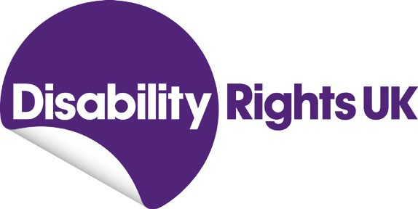

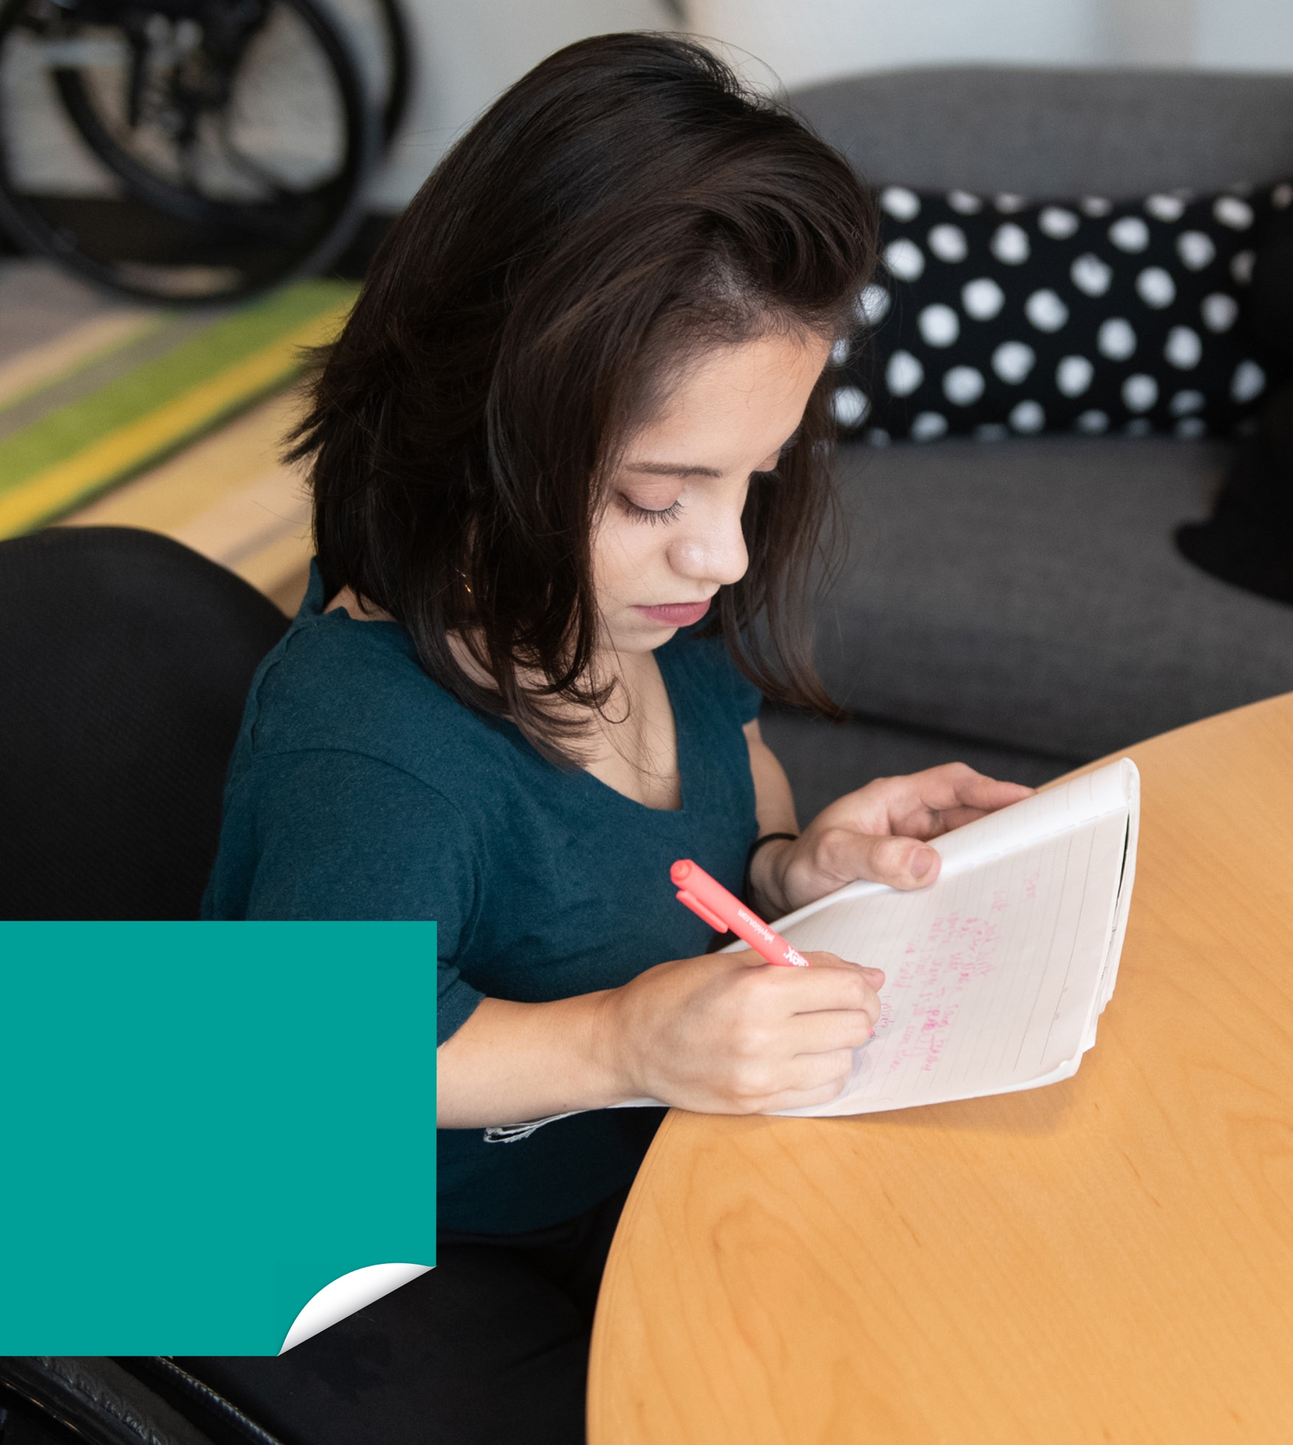

Getting it right for Disabled apprentices
Rabia Lemahieu
January 2022

Photo © Disabled And Here

Contents

Acknowledgements 3
Foreword 4
Executive summary 5
Introduction 7
About the Disabled Apprentice Network 8
What Disabled apprentices told us 9
Choosing an apprenticeship and the best parts of it 9
Language and terminology 10
Sharing information on disability 11
Reasonable adjustments and support 12
Lessons for employers and training providers 15
The Access to Work scheme 16
Ideas for change 18
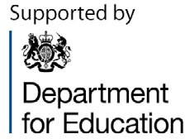
Resources 19

After many years of working in the training and employment field, it’s been a fascinating process to capture the experiences of a group of young Disabled people on taking part in an apprenticeship scheme.
Acknowledgements
My thanks go to the Department for Education, which commissioned and funded this report, as well as Disability Rights UK’s continuing work in the apprenticeship field.
Thanks are also due to colleagues at DR UK for their support in helping to bring this report to fruition, especially Fazilet Hadi.
But most of all, I want to acknowledge our past and present apprentices who make up our Disabled Apprentice Network and agreed to be part of this report.
They shared freely of their time and energy as we explored their experiences
detailed in this report. They spoke candidly, thoughtfully and directly about sometimes challenging and very personal issues.

Most importantly, their experiences show ‘the art of the possible’ to other young Disabled people considering taking up an apprenticeship as a route to employment.
To all of them – a big thank you.
Rabia Lemahieu
Disability and Skills Manager Disability Rights UK

Over the past year, I have had the privilege of listening to young Disabled people talking about what made their apprenticeships
Foreword
a success.
They had different ambitions, different experiences and different ways of tackling challenges but they were all honest, open and prepared to share their learning. For them, apprenticeships provided that all important first step on the job ladder and
I have no doubt that they will all go on to have interesting and fulfilling working lives.
The employment rate of Disabled people is almost 30 percentage points behind that of non-disabled people. For young people growing up with impairments or long term
health conditions, it is vital there are a range of routes into work and they receive early advice and support to help them make the best choices. For some young Disabled people, apprenticeships will be the perfect way of moving from education into the world of employment.
This compilation of the thoughts and views of young Disabled apprentices will help
to raise awareness of apprenticeships amongst young Disabled people, and provide some great tips to apprentices, employers and training providers on how to make apprenticeships a success.
There is so much wisdom in the views expressed in the following pages but if I were to have to choose one overarching
message, it would be the power and importance of open and honest
conversations. Such conversations mean better understanding and, crucially, can help start a concrete process which best supports a Disabled apprentice.
We, as Disabled people, have individual needs and ambitions. To enable us to flourish in employment we need to be able to articulate our needs and for employers to respond with positivity and a can-do approach. Creating an inclusive working environment, where we can all contribute our talents, is good for us all.
Fazilet Hadi Head of Policy
Disability Rights UK

Introduction
Executive summary
- This report explores the experiences of young Disabled people who are using, or have used, apprenticeship schemes as a route into employment
- Apprenticeships offer training alongside paid employment and the government want to see more disabled people benefit from the scheme
- It looks at what works well and covers people’s experience of training providers and employers, as well as
the support they received, including the government’s Access to Work scheme.

The Disabled Apprentice Network
- A network of Disabled people who are undertaking or have finished an apprenticeship
- The Network includes people who have done part and full time apprenticeships across a range of disciplines including media, business administration and working with young people.

What Disabled apprentices told us
Choosing an apprenticeship and the best parts of it
- Apprentices gave a wide range of reasons for choosing an apprenticeship
- These included being advised to by mentors or colleagues, building confidence and working towards a formal qualification whilst earning a salary.

Language and terminology
- Apprentices were concerned about how they were described as Disabled people
- They had strong views but didn’t always agree on which terminology to use
- They highlighted the importance of individual views and wanted employers to be proactive and ask about people’s personal preferences.

Sharing information on disability
- Apprentices had a range of views about talking about their conditions with employers
- They felt it was important for the individual to be in control of those conversations
- They wanted employers to ask open questions about how people could be best supported to do their job well.

Reasonable adjustments and support
- Some apprentices were not aware of what support was available, or that reasonable adjustments were a legal requirement
- Most said that they received good support from employers and training providers, but some were worried about instigating a conversation on the support they needed
- They wanted issues about support they needed at work to be raised at an early stage, and to be part of an ongoing conversation
- Some apprentices thought the idea of a ‘workplace adjustment’ document for individuals was useful.

Lessons for employers and training providers
  - Apprentices wanted conversations about disability to be normalised, and for organisations to demonstrate they were inclusive
  - They highlighted the importance of disability equality training to help embed a culture of inclusion in organisations
  - They spoke about the initiatives they found helpful, such as mentoring schemes.

The Access to Work scheme
  - Most apprentices had experience of the Access to Work scheme and had equipment or support funded through it
  - Many highlighted the delays they experienced, waiting for equipment to arrive and be put in place
  - Some said young Disabled people should be told about the scheme early so they knew about it when they were talking to potential employers.

Ideas for change
- Organisations should develop a culture which welcomes Disabled people
- Language is important and organisations should take a person-centred approach
- Conversations about disability, health conditions and impairment should be normalised and led by Disabled people
- Discussions about reasonable adjustments should be part of regular conversations, with employers having clear processes to follow
- Organisations should make sure they are fully informed about the Access to Work scheme, and Disabled people should be informed about it from a young age.

The government says in the National Disability Strategy that it wants to increase the number of Disabled people entering into apprenticeships. “…we want to ensure that those who start an apprenticeship
Introduction
go on to thrive. Our ambition is for more disabled people to undertake and achieve an apprenticeship.” (Page 59).
Apprenticeships offer a combination of work and learning for those over the age of 16 and are available for a wide range of job roles across many different industries.
Doing an apprenticeship gives a person the opportunity to work alongside experienced staff, gain the skills necessary for work, study for a particular qualification, earn a wage and establish a career path.
The Department for Education is working with different stakeholders, including Disability Rights UK, to improve the diversity and accessibility of apprenticeships. We have formed the Disabled Apprentice Network to understand the current barriers people may face in undertaking an apprenticeship, identify what works and co- develop solutions which support Disabled people to undertake apprenticeships.
We collected the views and lived experiences from 15 Disabled apprentices at a series of online meetings in 2021 as well as from questionnaires and other written responses.
Below we cover what made young Disabled people choose apprenticeships; ways in which they have benefited from them; thoughts on how they describe their identity as Disabled people; different perspectives on sharing information on their disability
or health conditions with employers and training providers; and the importance of appropriate support at work including legal responsibilities such as reasonable adjustments, feeling included and using
the government’s support scheme Access to Work.

Convened by Disability Rights UK, the Network brings together 15 Disabled apprentices and some who have now finished their apprenticeship. They explore their experiences about barriers
About the Disabled Apprentice Network
Disabled apprentices encounter on joining, and undertaking, apprenticeships; and suggest ideas and solutions to make apprenticeships more accessible for Disabled people.
Their expert advice on key issues provide insight for Disabled people who are interested in doing an apprenticeship, and for employers who are considering taking on a Disabled apprentice.
Members of the Network do full and part- time apprenticeships in various sectors and at different levels, including business administration, adult care, working with young people, learning and development, media, early years and management.
Thanks go to them and all who contributed to this report.
Alex | Harry | Lauren
Cameron | Ibrahim | Luke
Ellie | Jamie | Marc
Emma | Jessica | Scott
Eve | Kelly | Vicki

Ellie

Alex

Harry

Marc
Scott

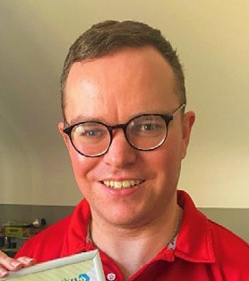

Kelly

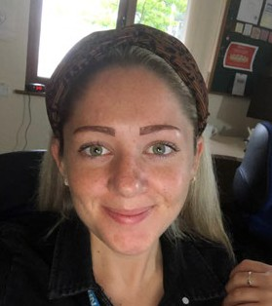

Luke

Why I chose to do an apprenticeship and the best parts of undertaking one
What Disabled apprentices told us
Apprentices gave a wide variety of responses as to why they chose to do an apprenticeship, including being advised to by a workplace mentor, wanting to get a degree with practical experience and to further their development in their chosen field. They were also influenced by the opportunity to build confidence, skills
and networks with people with different experiences and gain paid work experience.
Apprentices shared their thoughts on the positive experiences that doing an
apprenticeship brought and why they would recommend it as a route into permanent employment for Disabled people.
Some talked about the type of training they received, others on earning a wage. Other ‘best parts’ included the importance of receiving a formal qualification; being able to choose an employer; being part of the ‘apprenticeship community’; being able to use their learning in the workplace; and the structured support they received.
“

I…wasn’t too sure at the time [doing an apprenticeship] but decided to and it’s the best thing I had ever done.

Marc

The best thing about being an apprentice is that you are learning valuable skills and earning a wage at the same time. Choosing to become an apprentice means you are in charge of the best learning path for your career – you choose which
“
apprenticeship programme, which employer, which training provider and most of all you choose your own success and goals for your future.

Ellie

The best part of the apprenticeship was learning about the business side of the company and how we can
“
help clients fulfil their potential, and learning new skills that I can take into employment in the future and continue to build on the skills to make me a better employee and better at my job.

Luke

The best part was joining networks for apprentices, to meet others, widen my network and celebrate our successes together.
“

Alex

Meeting and greeting different types of customers and feeling productive whilst on my apprenticeship, meeting new people and being treated as
“
an equal.

Scott

The language I use to describe my disability
Apprentices raised concerns about how they are described as Disabled people, and the assumptions people make about them, particularly when they have a non- visible disability, or one that isn’t obvious. The term ‘Disabled people’ is commonly used amongst most people who are protected under the Equality Act 2010 but our respondents thought that when describing an individual, it can take on a different perspective.
Language is a deeply personal thing and they expressed different views about how they prefer to describe themselves. Some preferred person-first language; others had quite specific preferences, for example, being described as ‘someone with autism’, rather than ‘an autistic person’.
“

For years I have been saying ‘I have autism’ instead of ‘I am an autistic person’. The National Autistic Society says the correct term is ‘autistic person’. In my heart/head I felt autistic should not come before the person.
Using first person centred language, I have changed from saying ‘I have autism’ to ‘I am autistic’.

Harry

My language has changed. When 12/13 years old, I would say ‘Disabled people’. After university and work,
“
it is now ‘person with a disability’.
But it also depends on identifying individually. It is like giving that person power themselves so they can define how they want to be called and having that conversation before you carry on talking to them; so you can ask on a personal level.

Luke
I quite like the term ‘person with’. Just because I like to think I am a person before my disability and that is quite important to me as I like people to see me as who I am, rather than my disability, especially as I have quite an
invisible disability. A lot of people don’t see that, and I like that. I think people are treated differently with disabilities even though they shouldn’t be.
“

Emma

The important point about using specific language and terminology is thinking about why we use it. Apprentices did not want
to be labelled and expressed their right to define themselves and to be respected for that.
“

With language, for me it is it is less about what they say, but how they say it. I have never been offended by
people saying ‘you have MS, what can we do for this/that’. It has never been an issue if it is in that context.

Emma

Overall, respondents wanted employers to be proactive at an early stage and ask what people’s preferences were when it came to how they were described and the language that they use.

How I feel about sharing my disability with my employer
The Network had mixed views about sharing details of their disability or health condition with their employer. Some wanted to talk about this early in the process of taking on an apprenticeship, but some did not want to share it at all. One apprentice said she would now talk about it when starting a new job because she feels more confident but did not feel this way when she started her apprenticeship.
“

From my own experience, I always tell an employer that I am a Disabled person and have cerebral palsy quite quickly. It is a personal preference.
If you meet me, you can see I am in a wheelchair and prefer to tell them so they are fully aware of what can occur when talking to them. Cerebral
palsy sometimes gives me involuntary spasms. If they are aware first, then the conversation can continue and flow better. For me it is the best way.

Luke

I have only been diagnosed as autistic since last August because I am good at masking. So, from the outside I seem I am ok…but when I am open with it, people will shut me down,
“
like: ‘How are you autistic? You are absolutely fine’. I am quite reluctant to tell people, because they are dismissive, as if it does not exist.

Vicki

It did help for my colleagues to be aware of my disability…I decided it was best to tell them.
“

Cameron
Apprentices felt strongly they wanted to be in control of the conversation, but not everyone felt comfortable speaking early
on with an employer about their disability or health condition and wanted to mention it in their own time.
“

I wait until I am ready.

Eve

Some thought talking about mental health issues was more difficult and that some Disabled people would rather tell an employer they are physically ill rather than needing a day off because of depression. Most would agree employers are more responsive around issues of mental health than they used to be.
Apprentices also talked about whether an employer should invite you to talk about your disability at the job application stage or at the interview stage. For some it was important that it was asked at the application stage, so that the employer would know they needed to make a reasonable adjustment at the interview.
Others needed to know if the interview premises were accessible, with one wheelchair user saying he could not attend his first interview as the building had steps and no lift.

Under the Equality Act 2010, employers are not allowed to ask job applicants if they are disabled. They are allowed (and it is best practice) to ask job applicants if they need any adjustments in the event they are invited for interview.
“

When I go to an interview, I let them know I have a speech impediment/ stutter and that gives me ownership…when I let them know, I feel quite powerful with that.

Kelly

I know that I always worry when I tell people I have x, y & z and that they are going to think: ‘We don’t want to employ her because she is always going to be off sick or not able to fulfil the duty we are asking.’ That is something I have always been a bit
“
paranoid about. So I go into interviews telling them ‘I haven’t had a day off sick in six years.’ I feel I have got to get that in there, as I feel I am being prejudged, whereas if I have not told them, they don’t know that, so they are not going to be thinking that.

Emma

With job interviews it should be more about our skills and what we can bring to the job and not our disabilities.
“

Scott

For some apprentices, sharing the impact of their disability or health condition gave them ownership and a sense of control. It was important that communication with an employer was instigated by the individual. They did not want to wait for their disability to be spoken about. They wanted to raise the issue first and point out what would help them to be effective in their job.
Employers could support them in this by asking open questions about what support someone needs in order to do their job well, once a job offer has been made
and accepted.

Reasonable adjustments and support to help people work effectively
Some apprentices said they were not aware about reasonable adjustments when they started their apprenticeship. One apprentice left a full-time apprenticeship because his employer did not provide reasonable adjustments. He later did
a part-time apprenticeship, which he completed successfully. He said he would have considered asking for reasonable adjustments with his first employer if he had known about it.
For most apprentices the adjustments they received from both employer and training provider worked well for them.
If you have an impairment or health condition, your employer has to make adjustments to help you do your job. Under the Equality Act 2010 employers and training organisations have a legal
responsibility to make sure Disabled people can access jobs and training as easily as non-disabled people. This is known as the duty to make ‘reasonable adjustments’.
Reasonable adjustments are exactly that. What applies to a larger company may be different for a smaller employer to support Disabled employees. Most reasonable adjustments have a limited or negligible cost, although there is government scheme to help employers with any significant costs called Access to Work (see below).

Common reasonable adjustments include:
  - Flexible working patterns
  - Providing a quiet working space
  - Providing a designated parking space
  - Adapted office furniture and IT equipment
  - Additional mentoring or management support
  - Providing material in Braille, Easy Read or large print formats.
Apprentices received different kinds of adjustments and levels of support. Overall, they said that the adjustments their employers offered gave them the
right support to enable them to complete their apprenticeships. However, some said that they wished the employer asked about reasonable adjustments earlier in their employment.
“

[With previous jobs] I’ve never entered an environment where they even asked me if I’ve got any sort of needs or anything like that. So, to
come into this organisation [BBC], and straightaway on the form [they ask]: ‘Have you got any hidden disabilities?’
…then for them to follow up [and go] through what reasonable adjustments I could have in my day job and with the training provider…so on both parts. Amazing.

Vicki

My employer supports adults with learning disabilities anyway, so I had a really easy time. I come in and said ‘I am autistic’…and they gave me the support instantly.
“

Harry
When I started work, they were really understanding of my needs, because they already sort of knew me...how they could help me. When I started, I had a support plan.

Jessica
“

Some apprentices thought that some sort of ‘workplace adjustment’ document, which detailed the adjustments they need
at work, were a good idea and provided a record to help start a conversation about their disability or health condition and adjustments that would support them.
“

I used my reasonable adjustment request to think how I work...like taking regular work breaks, the opportunity to stretch my legs…I got equipment that has been adapted to support my hearing to be able to do my job…I had the opportunity to have a conversation with my manager and also had a written document called
a Workplace Adjustment Passport [in] which you can write what your disability is.

Alex

My employer and provider were very understanding on both my needs and disability.
“

Marc

We have an open-door policy at work so if we got an issue, we go straight to our line manager.
“

Ellie

I have sessions to kind of go through better ways of working. I’m dyslexic and I’m also autistic…it’s frustrating because they fight each other.
“

Vicki

Some said that having the confidence to speak up about what you need is very important. One person said that previously he would not ‘rock the boat’, but now feels confident enough to speak up if something needed to be said.
Apprentices said it was down to employers to make them feel comfortable, when asking for reasonable adjustments.
Some apprentices said employers asking about the adjustments they need, at the beginning of a job, and throughout the employment, is helpful because they can be difficult conversations to have; and also their health conditions can change during their apprenticeship.
Apprentices highlighted that having the right pieces of equipment was important for them to be able to do their work effectively.
“

In terms of employers…my first line manager helped me in terms of identifying how…I could comprehend information better. One of the things was to install a software program called Read and Write…it was not suitable for this particular IT kit I
had. The employer I am with right now, the civil service…there is improvement in terms of getting the right software programme.

Ibrahim
My apprenticeship provider once gave me a Dictaphone to help me record any NVQ work, but I didn’t really
use it.
“

Scott

Apprentices talked about fluctuating health conditions, where they have times when they feel less productive. They said that having regular sessions where the employers are proactive about changes in their condition or adjustments they need, would take the pressure off apprentices.
They also pointed out that, by the same token, it is important for a Disabled person to not just say ‘Yes, I’m fine’ if they are not and need more support. There should be a bit more exploring by both parties about how the work experience and environment can be improved.
Where employers are understanding, apprentices were able to make changes to their programme, with one apprentice
saying that after experiencing mental health issues, he was able to change his full-time apprenticeship to a part-time one.
Though some apprentices said they received good support from their employer, such as access to a confidential occupational health helpline, they were also aware that support and adjustments from employers can depend on how good communications and relationships are with a company or line manager, and the size of company.

What training providers and employers could do better
Apprentices discussed how they could educate and challenge employers about some of the negative stereotypes they have about what Disabled people can and cannot do.
They wanted conversations about disability to be normalised and part of an organisation’s culture in the same way as, for example, child care provision or flexible working practices are.
They also wanted organisations to demonstrate they welcome disabled applicants, for example by highlighting disability-friendly policies and using appropriate language in job adverts.
For example, some employers have a lot of assumptions about blind people because employers do not know about screen readers and understand about mobility and other adjustments that can be made. There are so many stereotypes and negative attitudes, and it’s important to find a way to show employers Disabled people can do a whole array of jobs.
Respondents said quite a few employers and organisations have training for line managers that would cover these kinds of conversations – this is an avenue to think about what goes into training courses for managers.
For the best outcomes, employers need a clear culture of disability inclusion
embedded in the organisation. This can be supported by early disability equality training for people joining the organisation as part of their induction.
There should be specific training for new managers to avoid the impression that disability inclusion is tokenistic.
Apprentices said that they were able to discuss what adjustments they needed with the training provider including learning support, extra time to finish assignments and the use of a quiet room for exams.
They also had regular meetings to track and discuss their progress on the course.
“

For me it is processing, more visual… I have coloured lenses I sometimes wear…College were a great help for me because I got extra time in exams and…I had more time to revise.

Ellie

I was allowed extra time to complete assignments.
“

Cameron

My learning provider asked me how I wanted to learn, and I told her…I can’t get what’s in my head out on paper
“
a lot of the time, and she went: ‘we’ll record it’, which is great.

Harry

I’m not judged on my writing...I get reasonable marking and they’re not going to judge me because I have not used a comma right or something like that.
“

Vicki

[My tutor] would make sure that I understood everything and would check if I needed her to go over
“
it again.

Jessica

One apprentice said that her health issues were highlighted through her school plan, but if a student didn’t have a similar plan to the one she had, they may not get that level of support.
Some found increased learning online [because of COVID-19] challenging, particularly when this was not communicated properly by the training provider.
Apprentices mentioned initiatives their training provider or employers implemented that had a positive impact on their working and learning. Mentoring programmes, for example, support people to speak in confidence on issues that worry them and allow them to be addressed at an early stage.
“

Every month I would have…an apprenticeship support mentor that came into my employer. It was like having…a counsellor, someone I could speak to that wasn’t at my workplace…which was fantastic!

Ellie

[The mentor] paired me up with other people…that had similar disabilities to me…or people that were from the same background…I was a business apprentice, so he paired me up with a business apprentice at a local solicitor. It was like networking – he
“
also proof-read anything I sent off. We edited it together, and having another perspective on it was great.

Ellie

We [NHS Foundation Trust] run a reciprocal mentoring program where senior banded colleagues/
“
consultants are matched with a junior banded colleague.

Kelly
Apprentices also said that they received support at the Endpoint Assessment, the final stage of an apprenticeship. It is an impartial assessment of an apprentice’s skills and knowledge.

When I did mine…I was worried about it, but with the support I got from my tutor and all the adjustments they put in about me having a break…it was great and was able to pass it and complete my apprenticeship.
“

Jessica

There is a possibility of me delivering my piece of training in front of a camera rather than having people there…they watch it back and assess my performance rather than being in the same room…I got the options… that was captured early on…which I really liked.
“

Kelly

The Access to Work scheme – government support for Disabled people at work
Access to Work (AtW) is a government funded scheme which provides support to Disabled people to get and keep jobs. This includes funding for employers to make reasonable adjustments to the workplace. Access to Work can fund things like:
- Taxis for people who can’t use public transport to get to work
- Support workers to carry out tasks Disabled people can’t manage because of their impairment or health condition
- Adapted equipment such as IT hardware and software
- The costs of putting written materials into a different format.

The network shared the different pieces of equipment and other support they received from AtW, including assistive technology such as voice recognition software and recording equipment.
“

When I started my apprenticeship, my management put me through to it. I was able to get some bits of
equipment and some sessions to help me with dyslexia. It was pretty easy
to do.

Lauren

I have a life scribe pen…an Echo Pen...it records the audio while I am writing, using that is quite helpful...
“
I love it.

Eve

One apprentice said Access to Work was ‘vital’ and it would be ‘impossible’ to do his job well without it. Most apprentices were positive about the support they received from Access to Work but not all of them knew about the scheme. Some
thought that the process took too long and that some pieces of equipment should have been delivered earlier to give them the support they needed at the start of their apprenticeship.
“

I have software, hardware and a personal assistant from AtW, which gives me independence and allows me to do the best job possible. I applied for AtW in September and did not get the grant until the following February. My grant took a long, long time to come through. It was a lot of ‘to-ing and fro-ing’.

Luke
I found out about Access to Work and got a chair through them, but it took over a year to get. With Access to Work luckily you can take it with you, so I took it to my new job.

Marc
“

Being able to get screen reader technology or overlay on screens were not that difficult to get, but it was much more challenging if it was not digital, and it took much longer to get the equipment delivered.
“

Jamie

Apprentices said that it goes back to knowing about AtW funding in the first place. Some said that if they had known about the funding when they were younger, the confidence to start looking for work at a younger age would have been there.
“

If you know early enough, then you can make plans.

Luke

They thought about who would be responsible to inform young people.
“

…if known in school it would definitely have helped to think about career choices. Maybe also getting this information from parents – it may mean more for a young person to hear this from a family member.

Alex

The ideas below aim to capture the key points made by Disabled apprentices on how to improve access and opportunity for Disabled people who have an interest in the apprenticeship scheme as a route to a career as well as employers and training providers.
Ideas for change
It is not a comprehensive list for organisations to tick off; rather, it is a series of prompts which may help Disabled apprentices in the future.

A culture of welcoming Disabled employees
  - It’s important for an organisation to have a culture where open conversations about health status, disability and impairment are welcomed and encouraged
  - Employers new to these issues could seek help and advice from other disability confident employers
  - Induction training for all employees should include disability equality training.

It’s not what you say, it’s the way that you say it
  - Employers should recognise there is not a ‘one size fits all’ approach to language
  - Language should be person centred and guided by the Disabled young person
  - Apprentices should be supported to share their preferences when it comes to how they want to be described.

Conversations about disability
  - Disabled people should be encouraged to be comfortable about talking about their impairment
  - Disabled people should be allowed to lead the conversation about their disability or health condition.

Reasonable adjustments in the workplace
- Questions about health changes or changes to reasonable adjustments should be part of regular conversations and appraisals
- Inclusive environments (such as how and where people work) should be encouraged
- Young Disabled people should be educated at a young age about the availability of reasonable adjustments
- Employers should have a clear process and culture around reasonable adjustments, including the provision
of ‘workplace adjustment’ documents for employees.

Access to Work
- Employers and training providers should ensure they are clear about the role and potential of the Access to Work scheme, and have a clear process for supporting young Disabled people to use it
- Young Disabled people should be given information on the Access to Work scheme at a young age so they are prepared to apply for relevant support when they reach the workplace.

18

Disabled Apprentice Network – includes videos and profiles of apprentices who feature in this report.
Resources
Government apprenticeship website Disability Rights UK website Government’s National Disability Strategy Government’s Disability Confident scheme The Access to Work scheme
Get Ahead – a resource by DR UK for young disabled people looking for information on post-16 opportunities in education, training and work.
Joe Grimshaw and Chloe O’Toole – videos of young Disabled people talking about their apprenticeships.
Amazing Apprenticeships – promotes apprenticeship opportunities and resources.
Disability Rights UK Student Helpline – Advice and information for Disabled people in education, apprenticeships, traineeships or supported internships. It is open on Tuesdays and Thursdays between 11am and 1pm.
Telephone: 0330 995 0414
Email: students@disabilityrightsuk.org

Edited and designed by
19

